***Lab File Part 2***

***Operating System***

***Submitted by   
Harshit Joshi***

***19bcs038***

***File Commands***

**Command : ls**

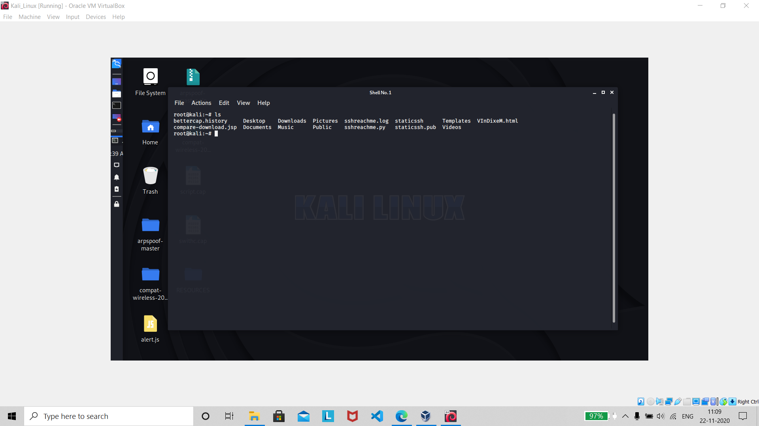

**About : The ls command is one of the basic commands that any Linux user should know. It is used to list information about files and directories within the file system.**

**Command : ls -al**

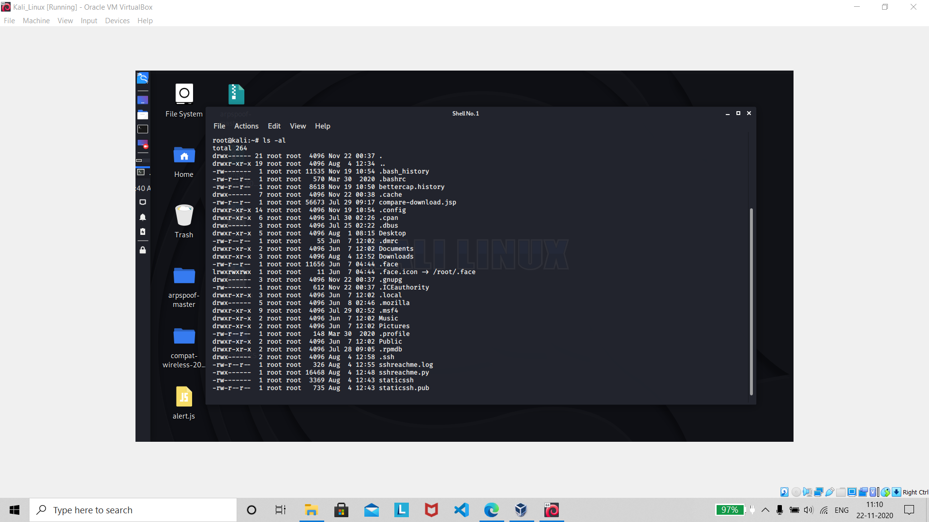

***About : Formatted listing with hidden files***

**Command : ls –lt**

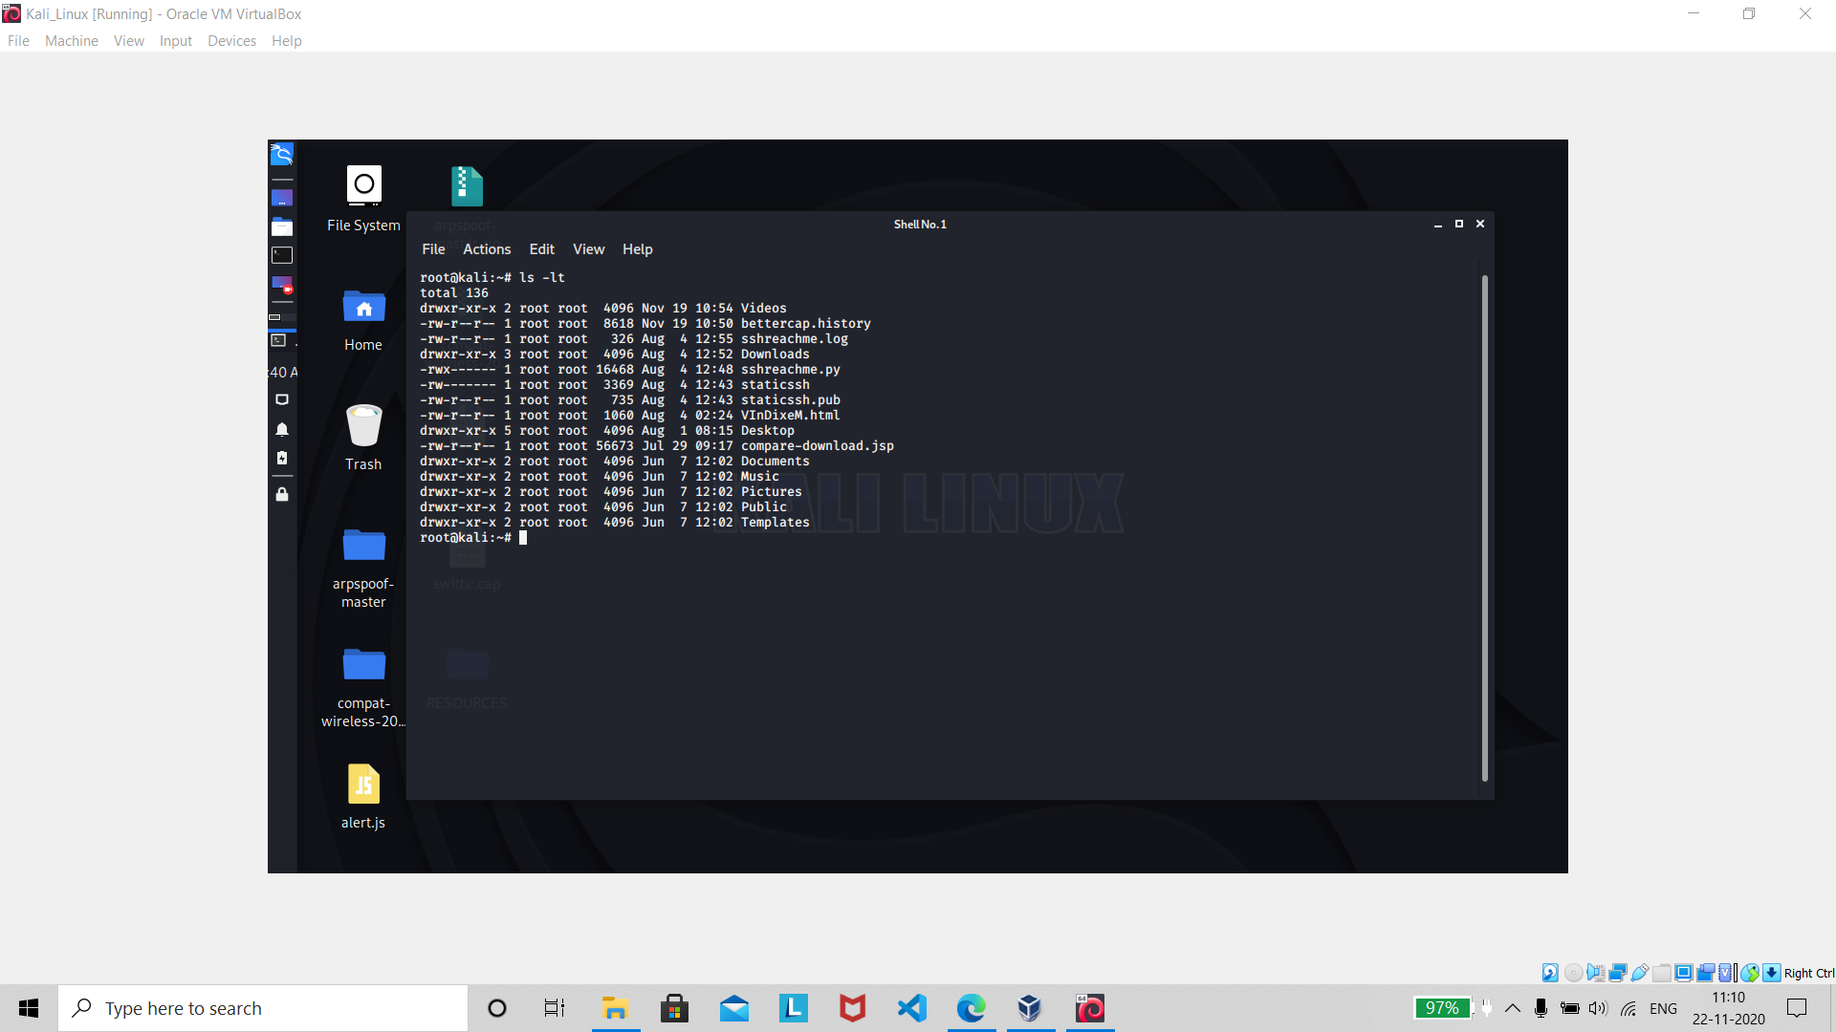

**About: Sorting the Formatted listing by time modification**

**Command : cd dir**

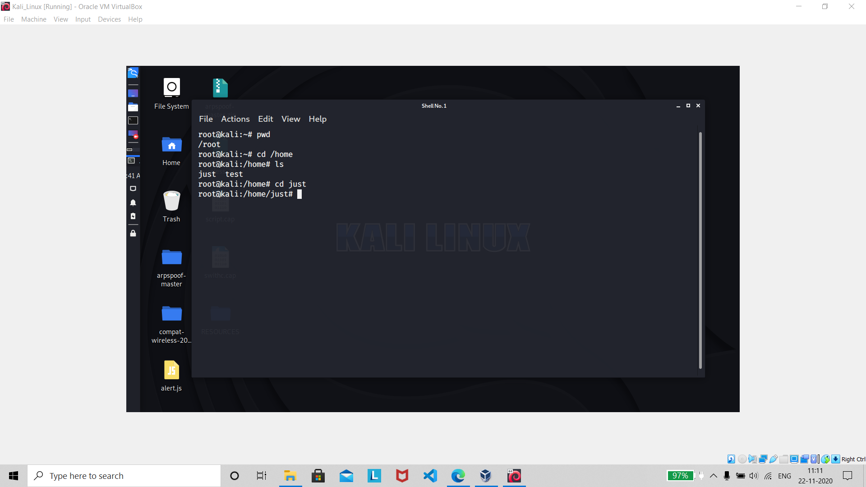

**About : The cd command, also known as chdir ( ch ange dir ectory), is a command-line shell command used to change the current working directory in various operating systems. It can be used in shell scripts and batch files.**

**Commands : cd and pwd**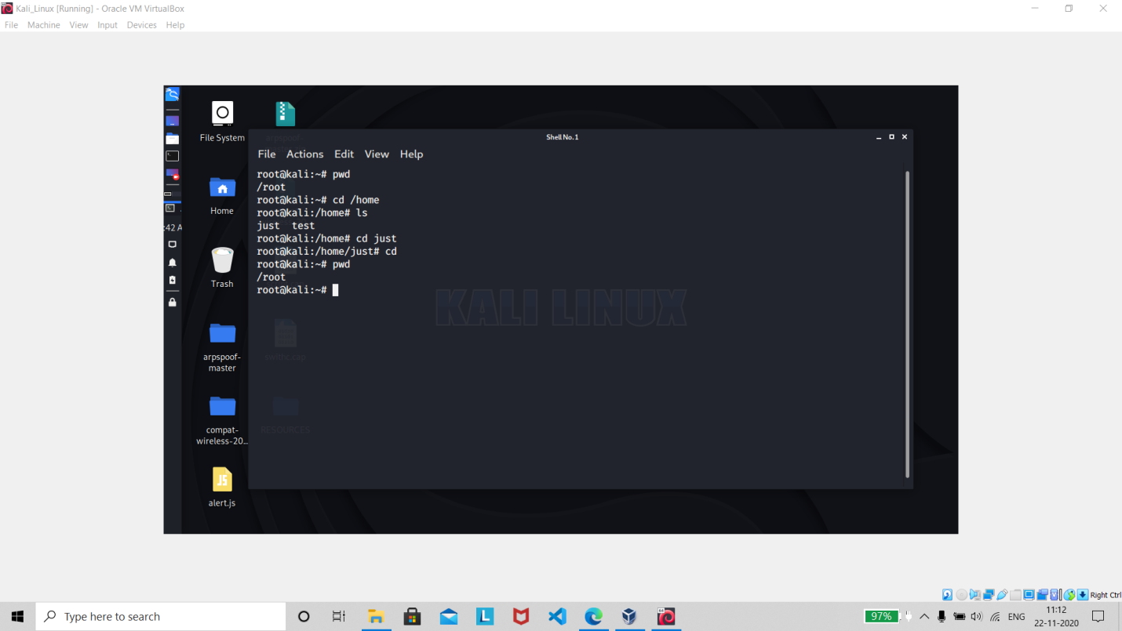

**About : pwd stands for P rint W orking D irectory. It prints the path of the working directory, starting from the root. pwd is shell built-in command (pwd) or an actual binary (/bin/pwd). $PWD is an environment variable which stores the path of the current directory.**

Command : mkdir dir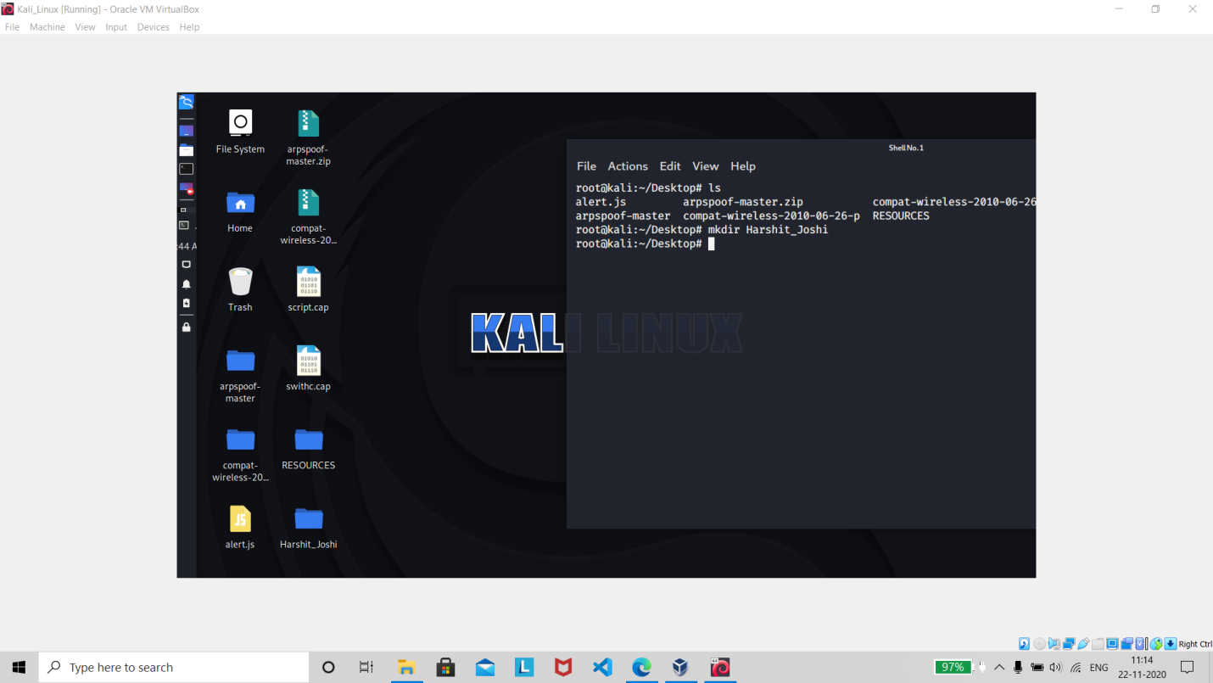

About : **The mkdir command is is used to create new directories . A directory, referred to as a folder in some operating systems, appears to the user as a container for other directories and files. However, Unix-like operating systems treat directories as merely a special type of file that contains a list of file names and their corresponding inode numbers**.

Command : cat>file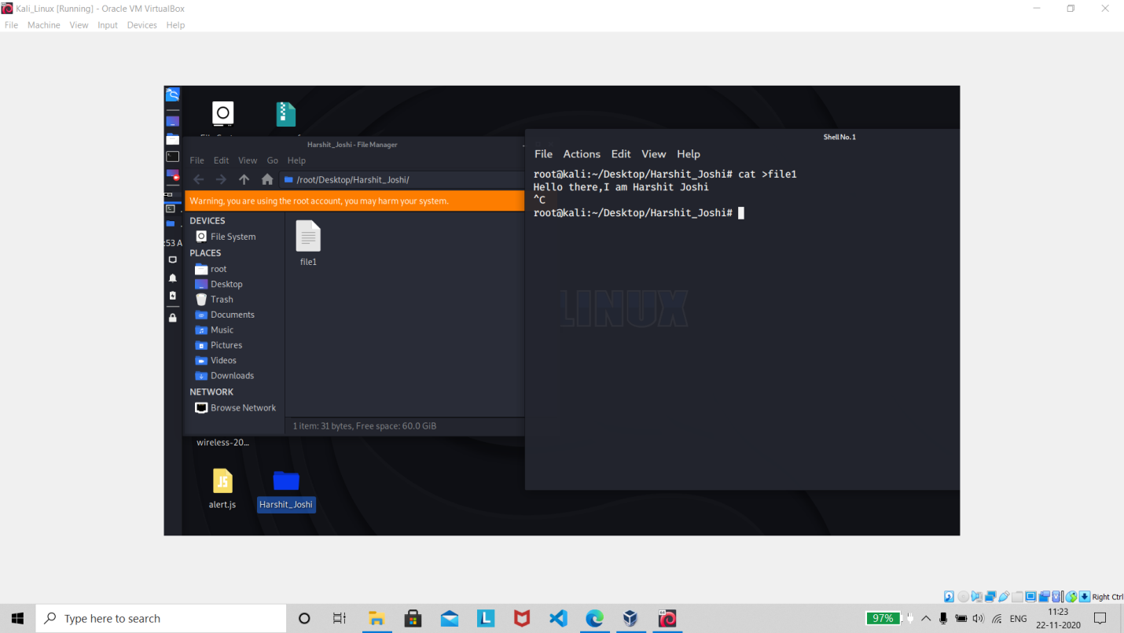

About : **The cat (short for “** **concatenate “) command is one of the most frequently used command in Linux/**[**Unix**](https://www.bing.com/search?q=Unix&filters=sid%3ab5967418-46d1-2f7e-470b-d1af3ce18cc8&form=ENTLNK)**like operating systems. cat command allows us to create single or multiple files, view contain of file, concatenate files and redirect output in terminal or files.**

Command : more file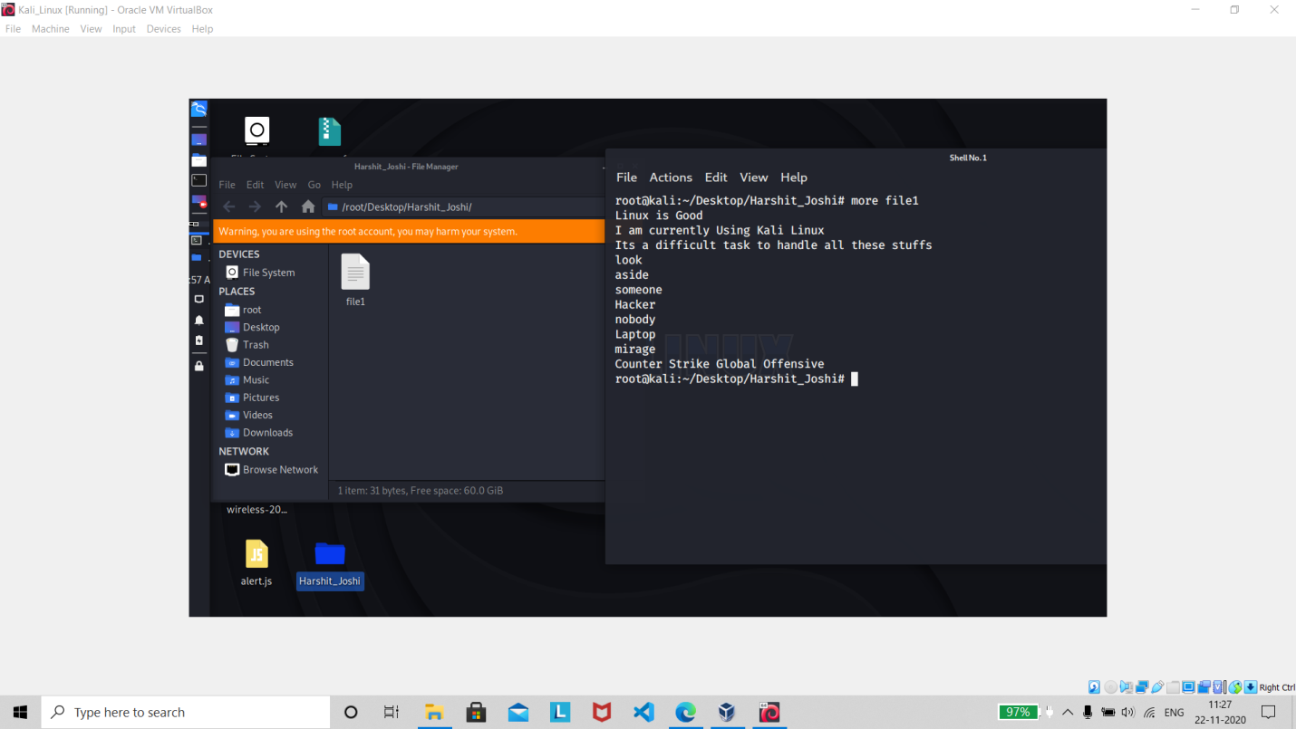

About : . **“more” command is used to view the text files in the command prompt, displaying one screen at a time in case the file is large.it Output the contents of the file**

Command : head file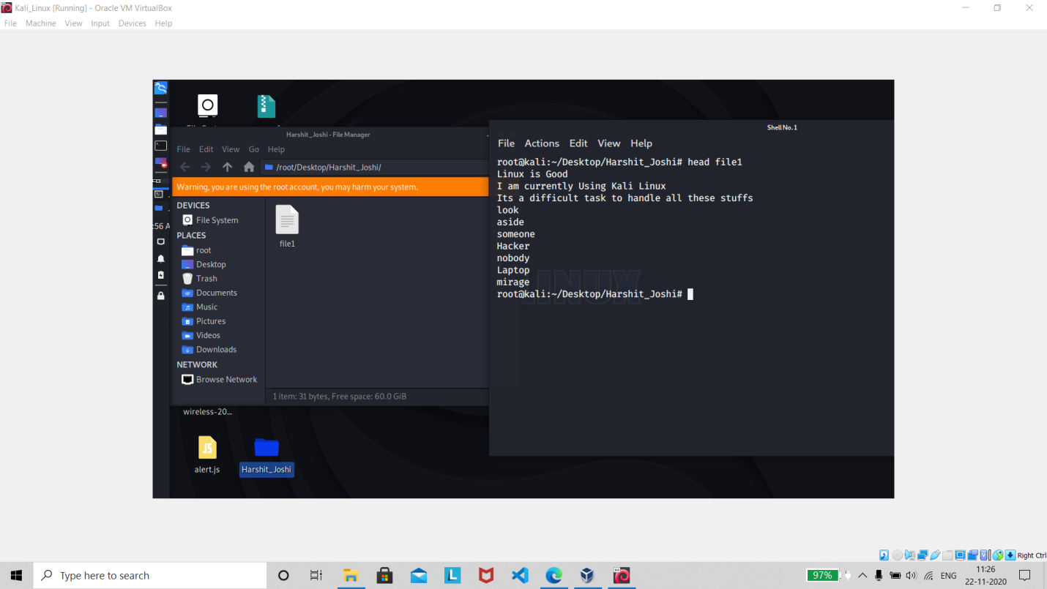

About : **The head command, as the name implies, print the top N number of data of the given input. By default, it prints the first 10 lines of the specified files. If more than one file name is provided then data from each file is preceded by its file name**.

Command : tail file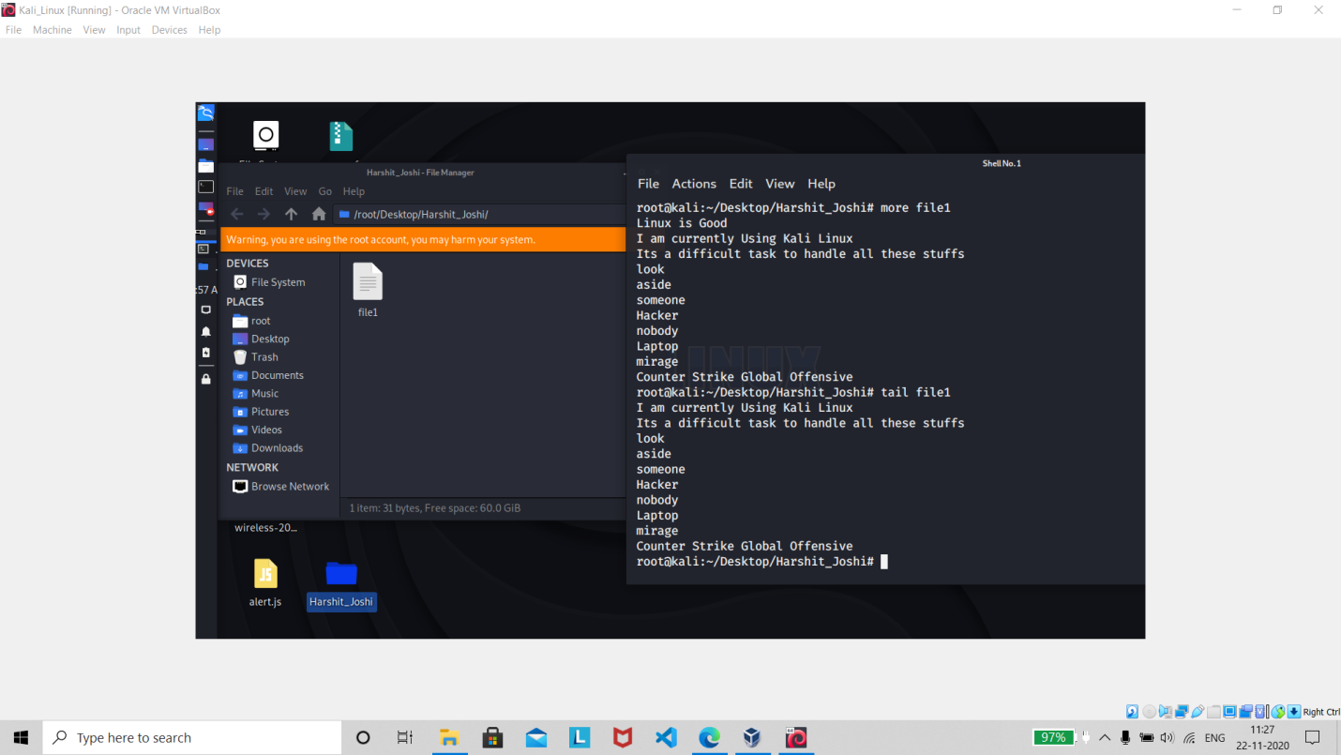

About : **Usually, new data is added to the end of a file, so the tail command is a quick and easy way to see the most recent additions to a file. It can also monitor a file and display each new text entry to that file as they occur. This makes it a great tool to monitor log files.**

Command : tail –f file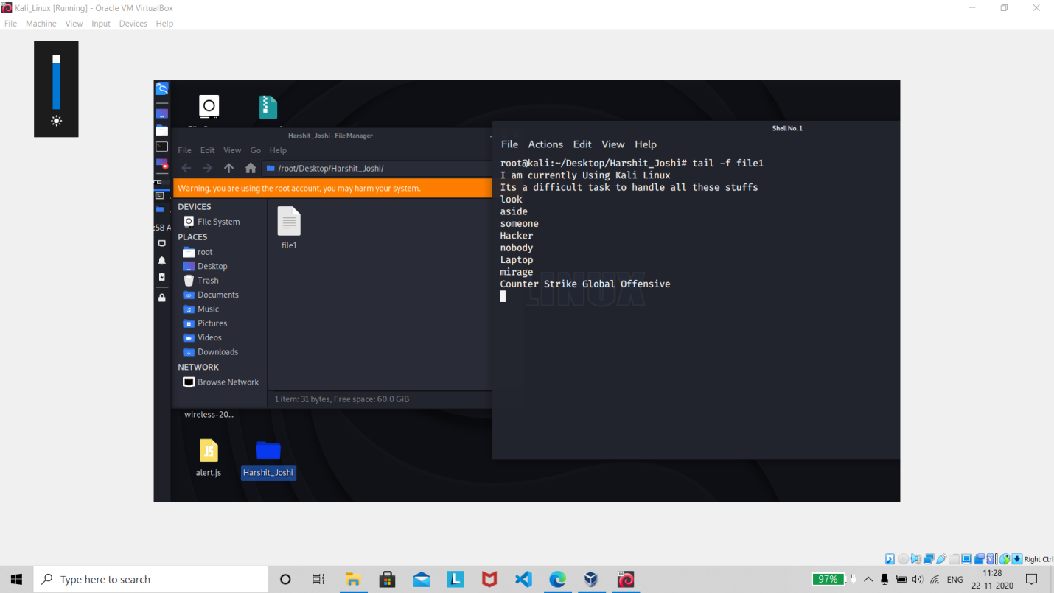

About : **Output the contents of file as it grows,starting with the last 10 lines**

Command: rm file 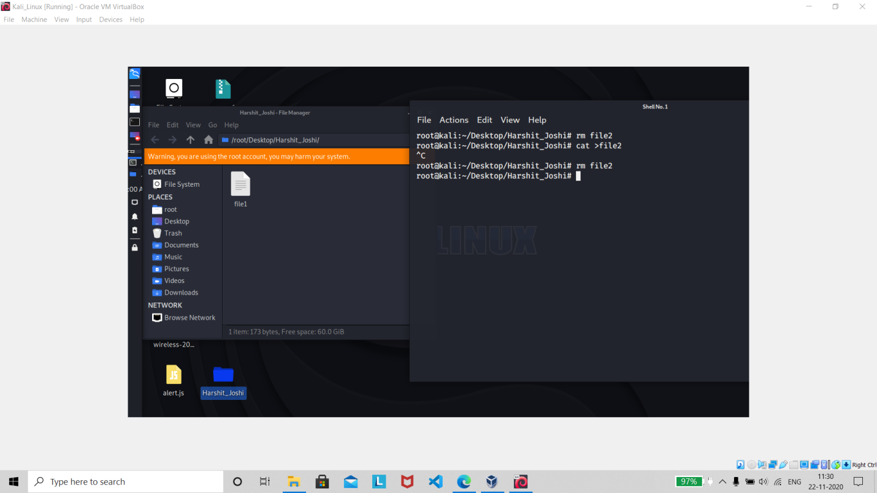

About : **In computing, rm (short for remove) is a basic command on Unix and Unix-like operating systems used to remove objects such as computer files, directories and symbolic links from file systems**

Command : rm –r dir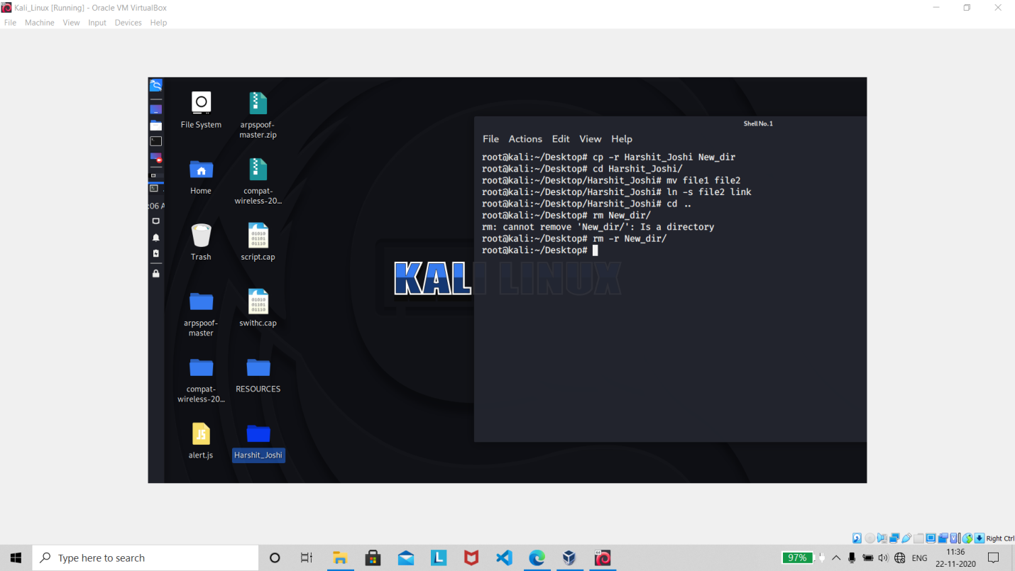

About : **Work same as ‘rm’ but it is used in Deleting the directory**

Command : rm –f file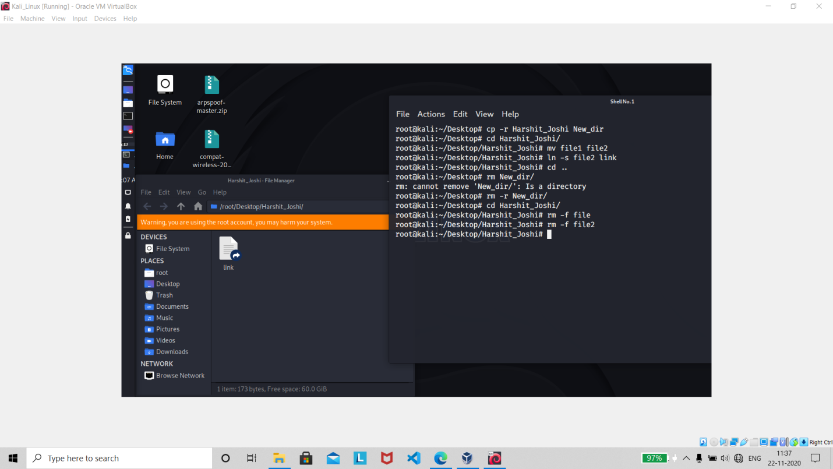

About : **Force to remove the file**

Command : rm –rf dir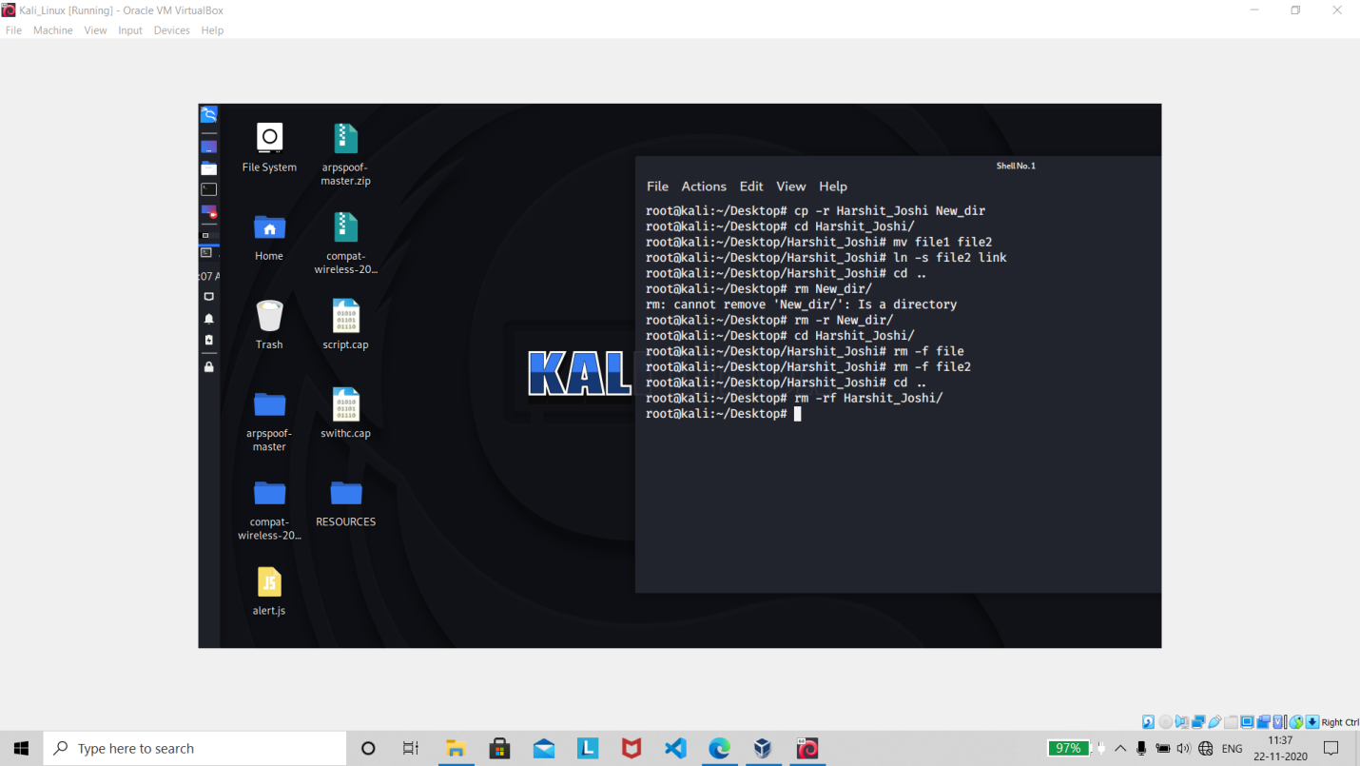

About : **Force to remove the directory dir**

Command : cp file1 file2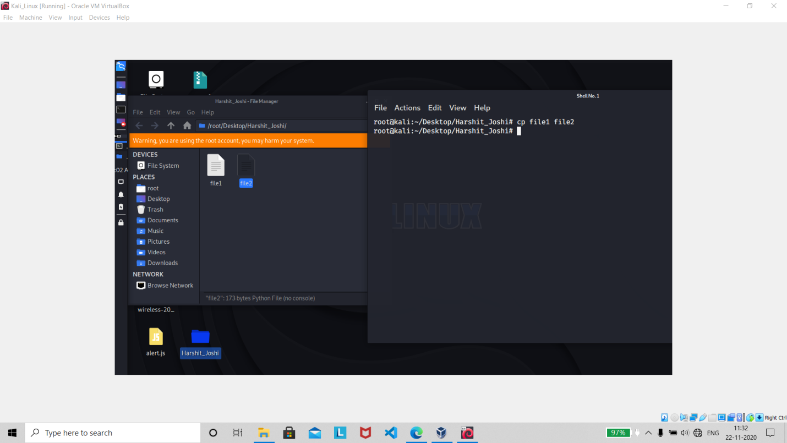

About : **cp command in Linux/Unix cp is a Linux shell command to copy files and directories.**

Command : cp –r dir1 dir2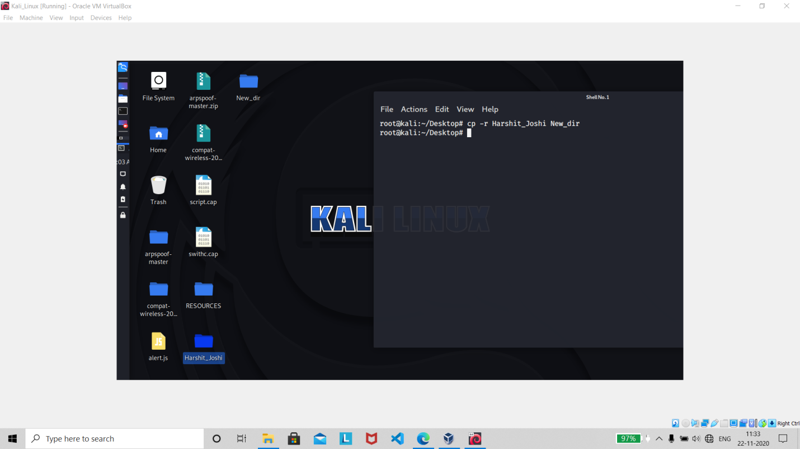

About : **Copy dir1 to dir2;create dir2 if not present**

Command : mv file1 file2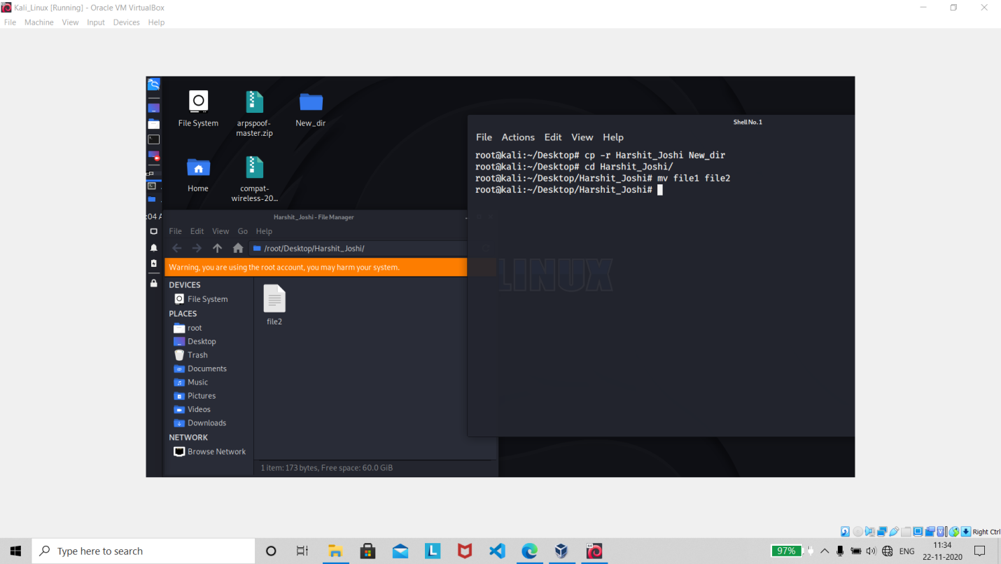

About : **The mvcommand is a command line utility that moves files or directories from one place to another. It supports moving single files, multiple files and directories.**

Command :ln –s file link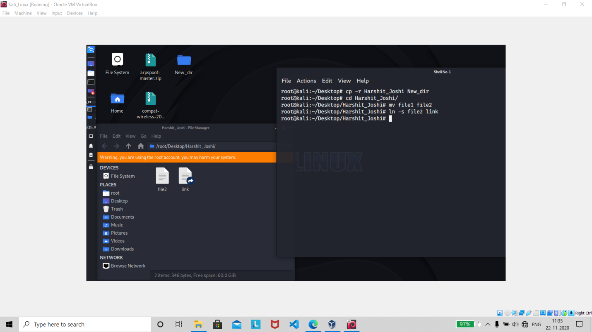

About : **The ln command is a standard Unix command utility used to** **create a hard link or a symbolic link (symlink) to an existing file**. **The use of a hard link allows multiple filenames to be associated with the same file since a hard link points to the inode of a given file, the data of which is stored on disk.**

Command : grep pattern file

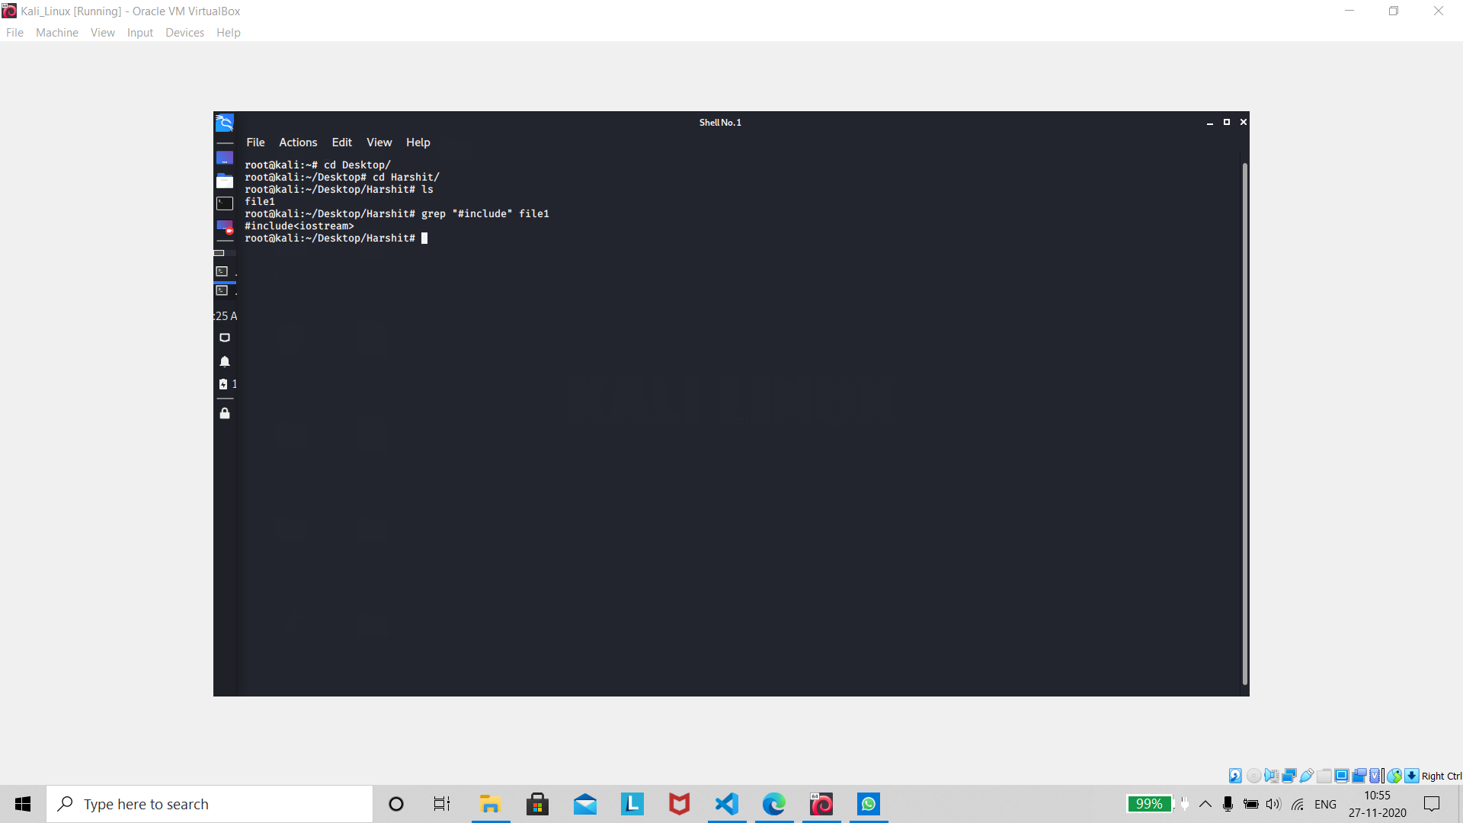

About : **Grep is a Linux / Unix command-line tool used to search for a string of characters in a specified file. The text search pattern is called a regular expression. When it finds a match, it prints the line with the result.**

Command : locate file

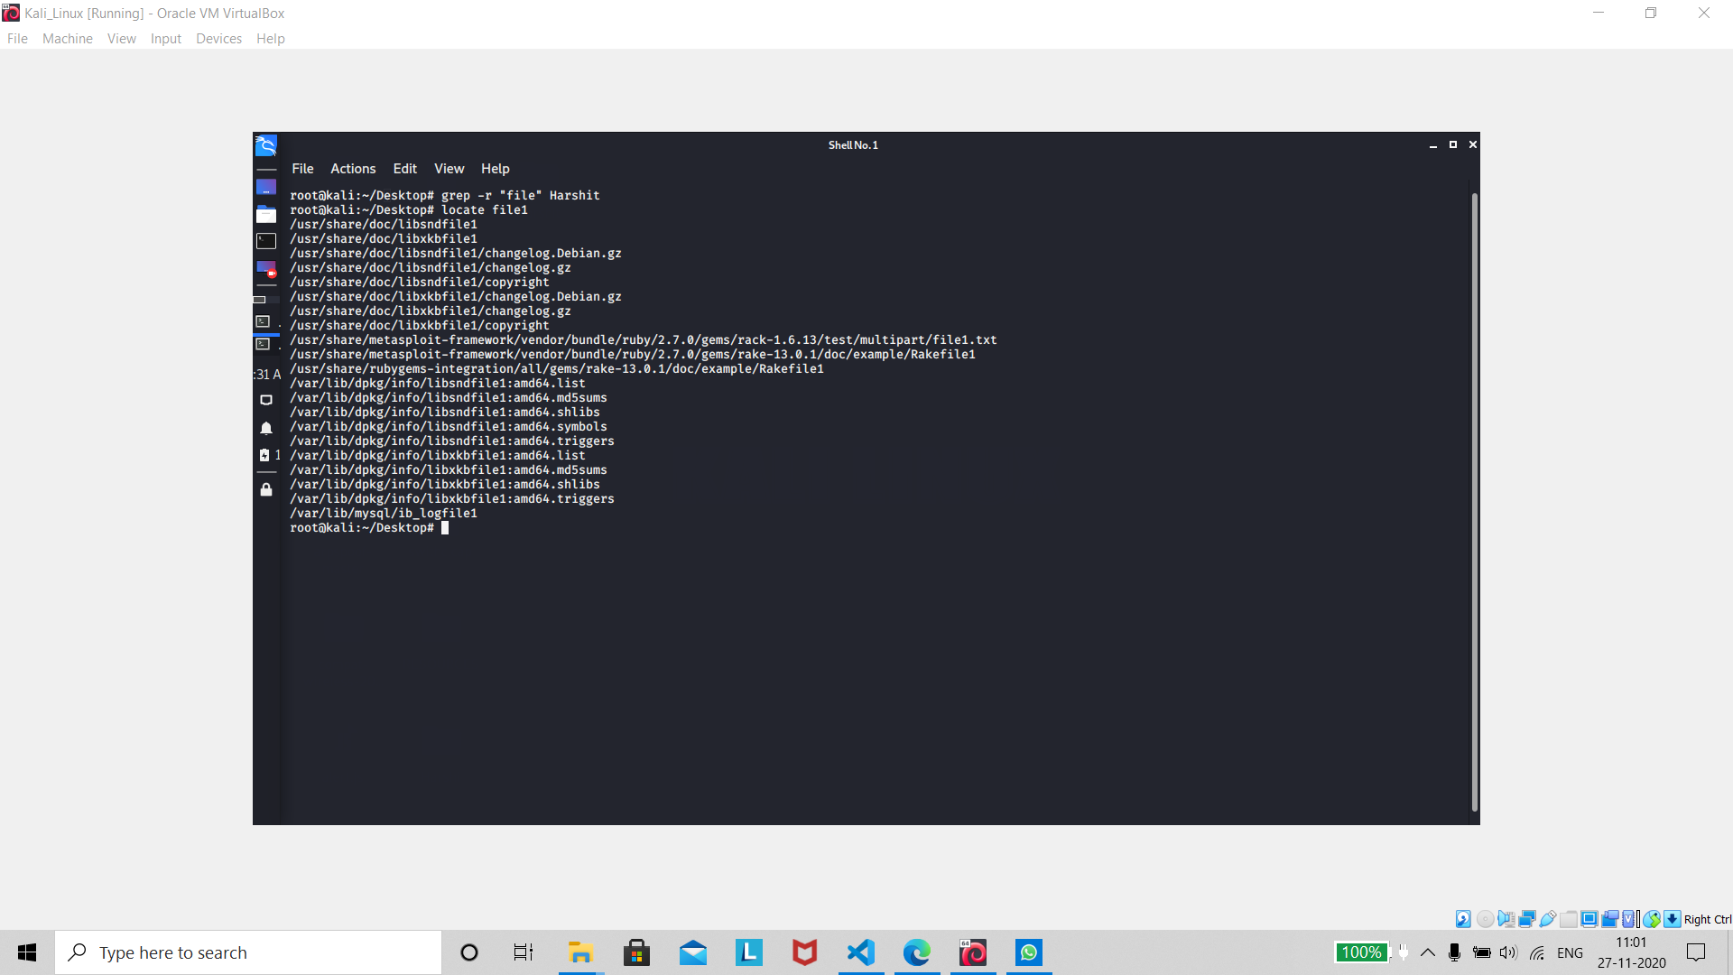

About : **locate command in Linux is used to find the files by name. There is two most widely used file searching utilities accessible to users are called find and locate. The locate utility works better and faster than find command counterpart because instead of searching the file system when a file search is initiated, it would look through a database.**

Command : find . –name filename

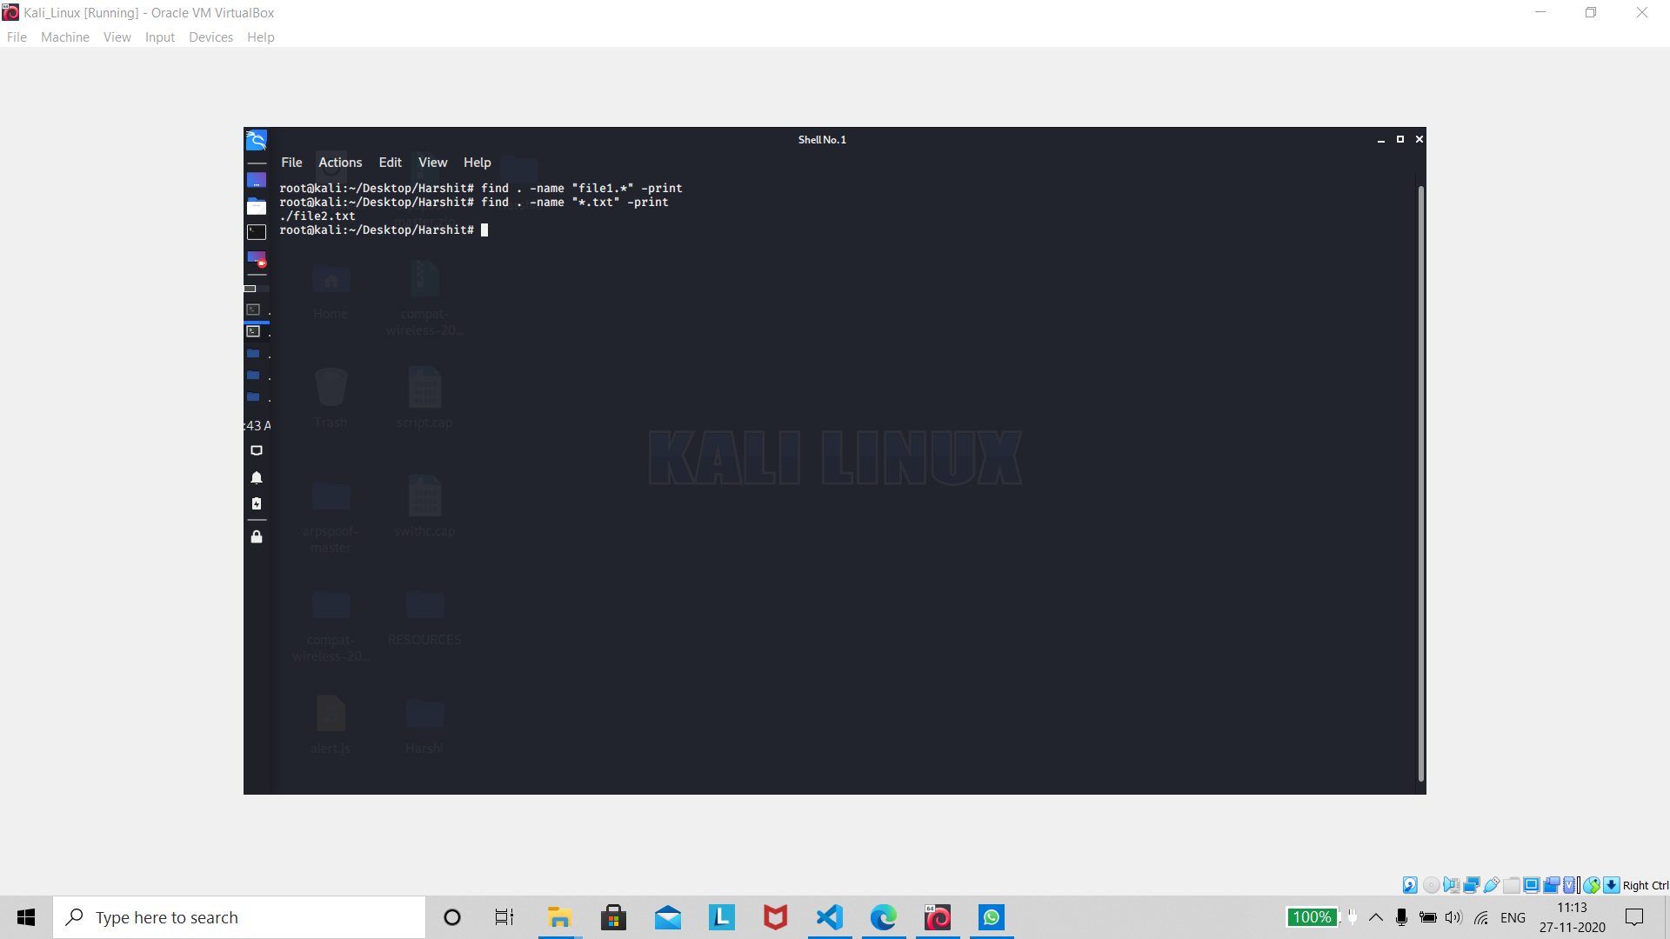

About : **The find command will begin looking in the starting directory you specify and proceed to search through all accessible subdirectories. You may specify more than one starting directory for searching**.

***Process Management***

Command : ps

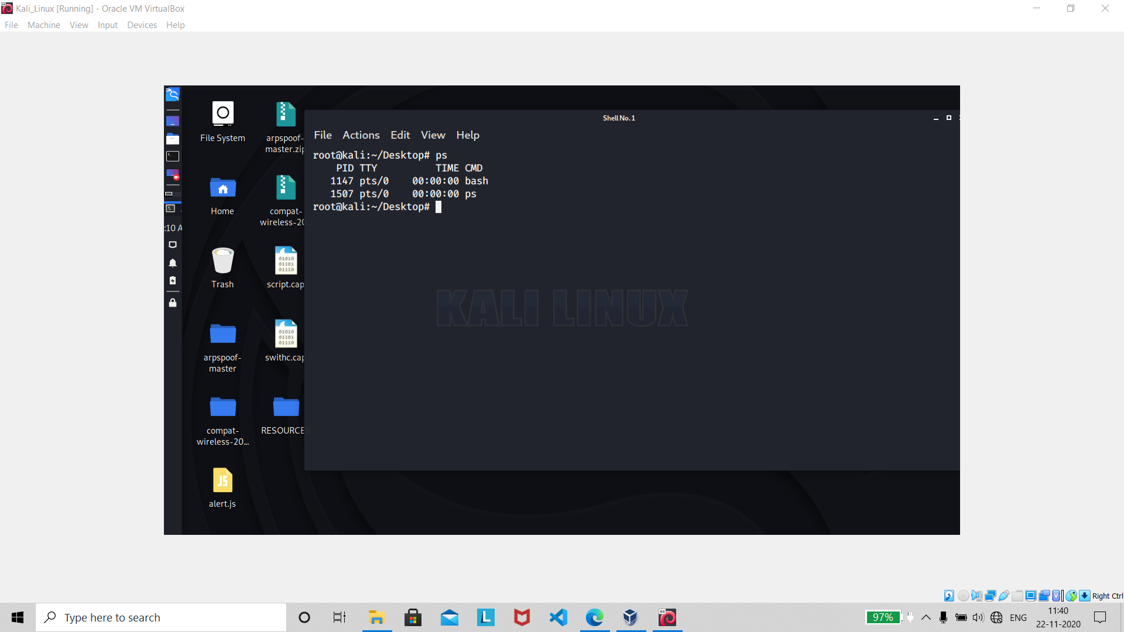

About : **The ps (i.e., process status) command is used to provide information about the currently running processes, including their process identification numbers (PIDs).**

Command : top

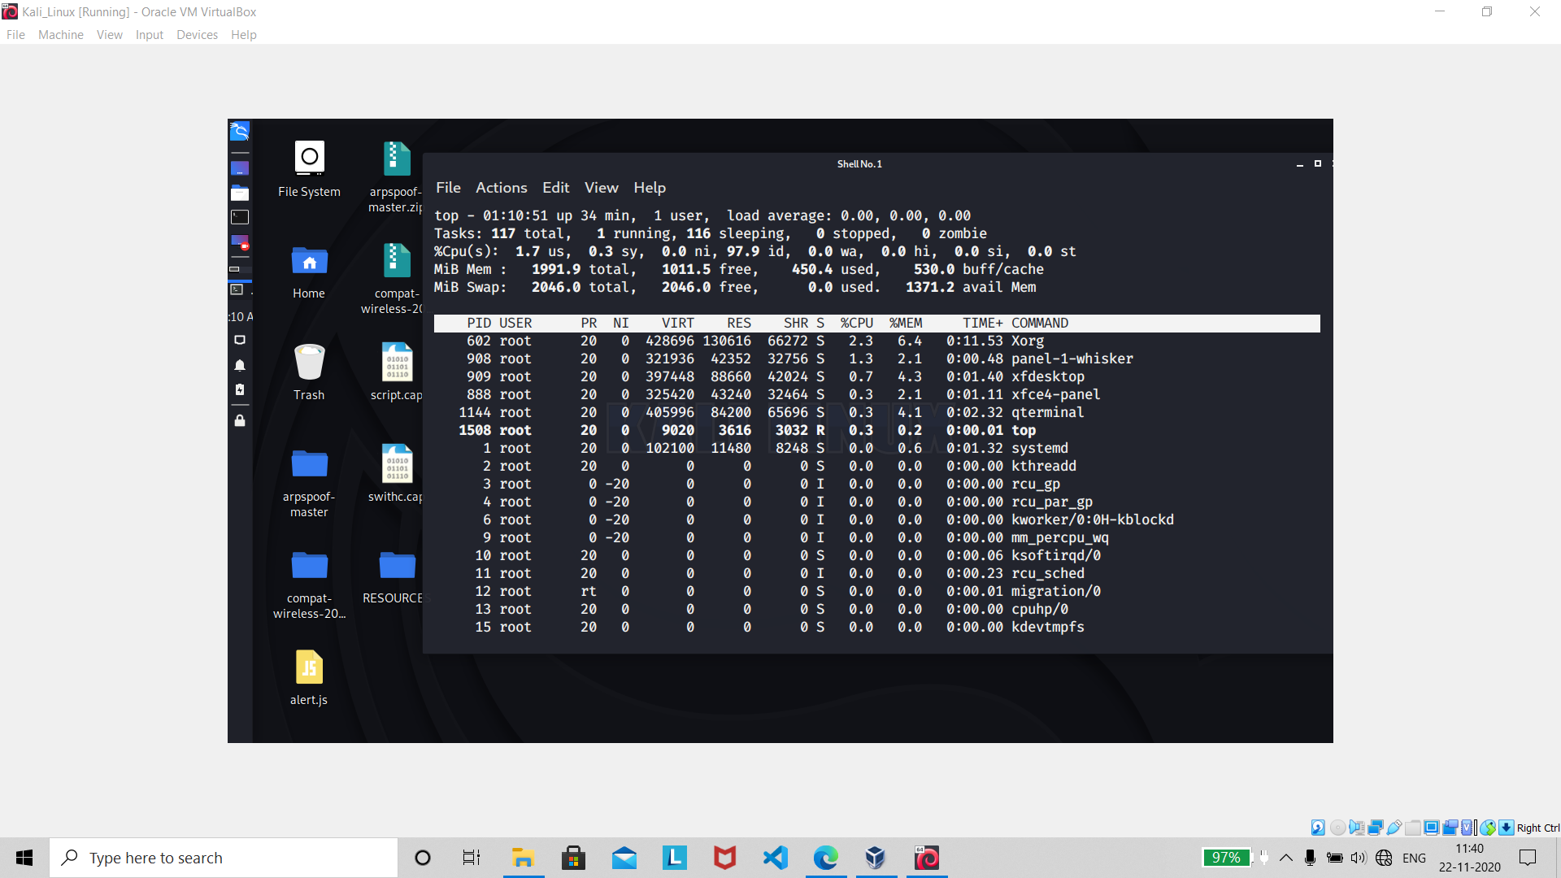

About : **Top command shows all running processes in the server. It shows you the system information and the processes information just like up-time, average load, tasks running, no. of users logged in, no. of CPU processes, RAM utilisation and it lists all the processes running/utilised by the users in your server.**

Command : kill pid

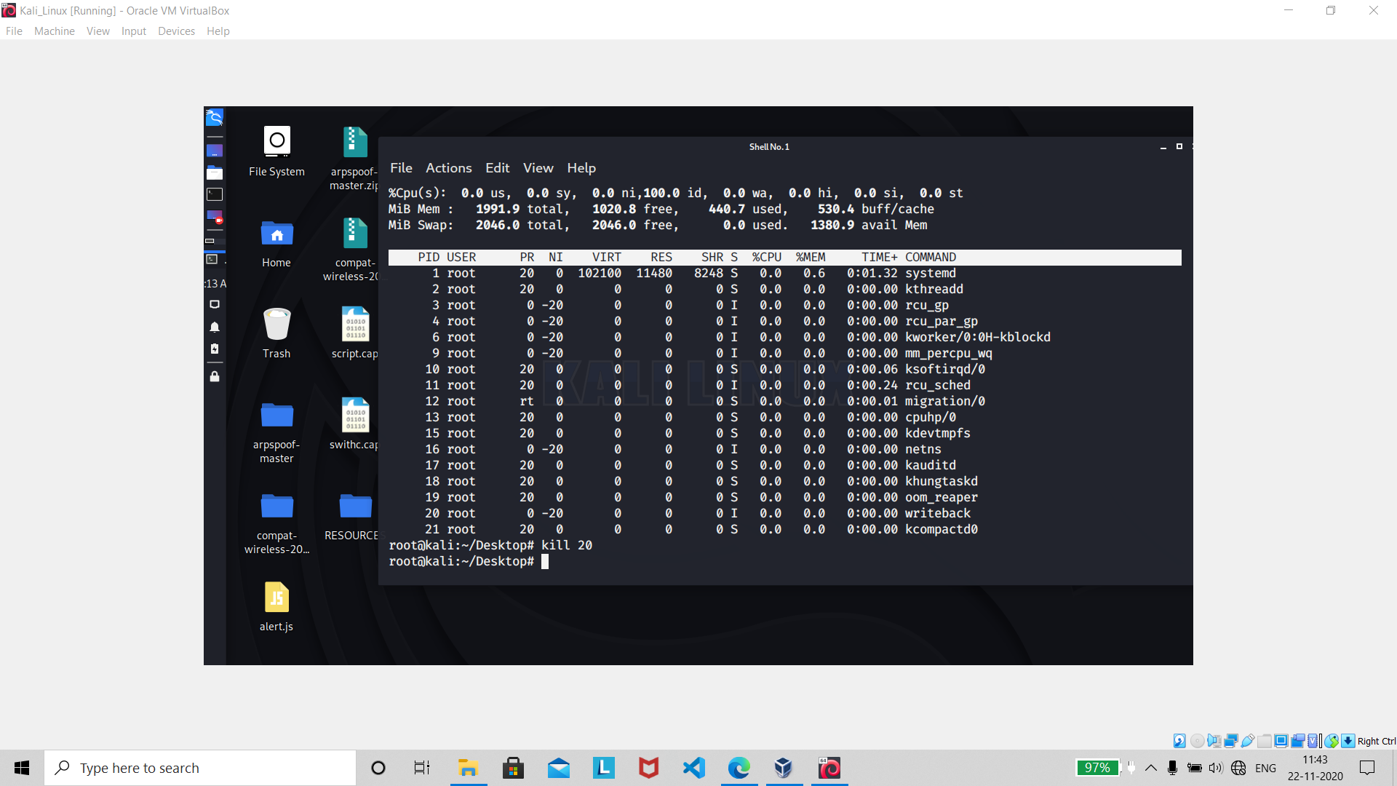

About : **kill command sends a signal to a process which terminates the process. If the user doesn’t specify any signal which is to be sent along with kill command then default TERM signal is sent that terminates the process**.

Command : kill proc

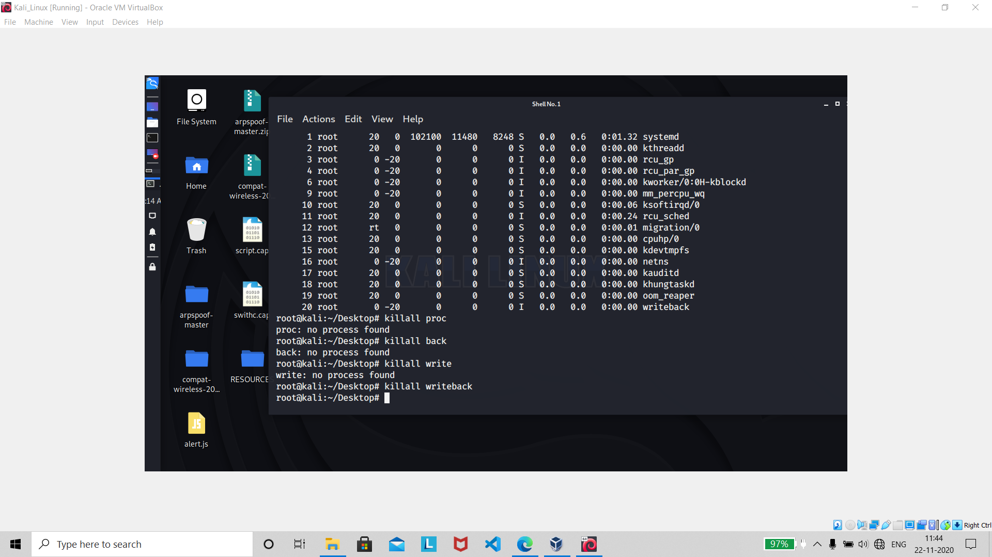

About : **The** **pkill command allows you to kill a process—or processes—by name**. **You do not need to identify the process by PID. To use pkill you provide a search term that pkill uses to check against the list of running processes.**

Command : pkill pattern

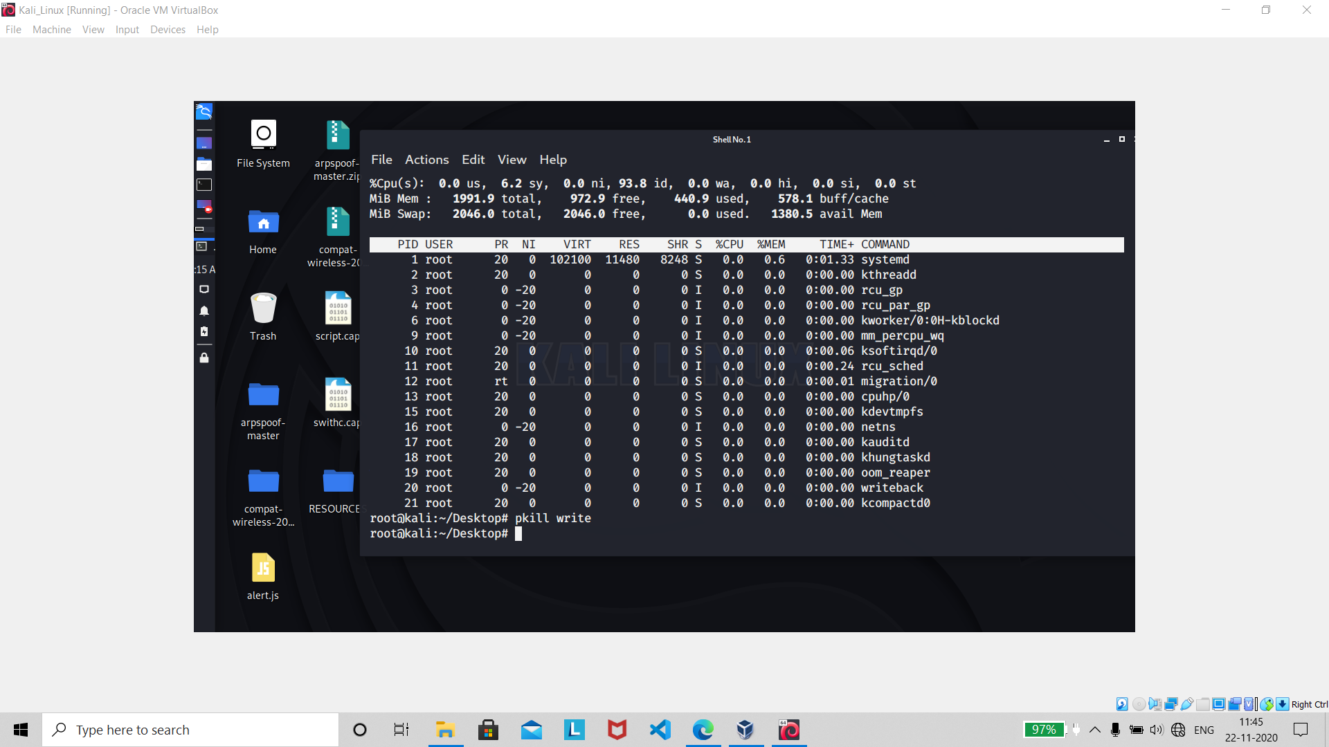

About : **The pkill command is similar to the pgrep command, in that it will kill a process based on the process name, in addition to other qualifying factors. By default, pkill will send the SIGTERM signal.**

Commands : bg and fg

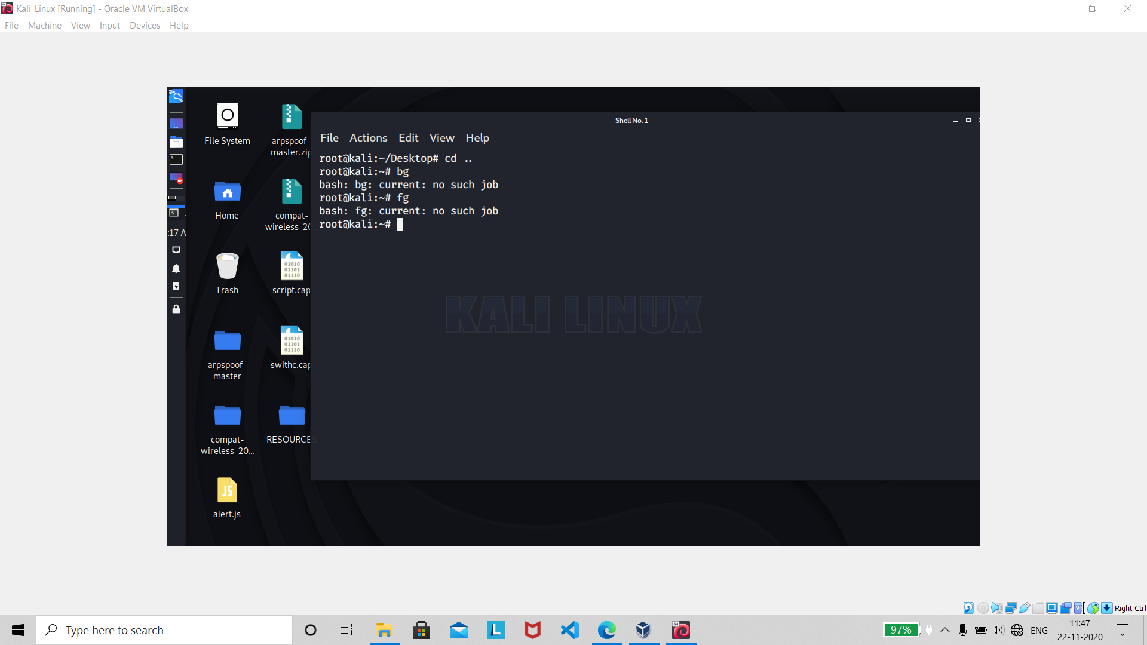

About (bg): **On Unix-like operating systems, bg is a job control command. It resumes suspended jobs in the background, returning the user to the shell prompt while the job runs.**

About (fg): **The fg command is like bg command except that instead of sending a command in the background, it runs them in the foreground and occupies the current terminal and waits for the process to exit**

Command : fg n

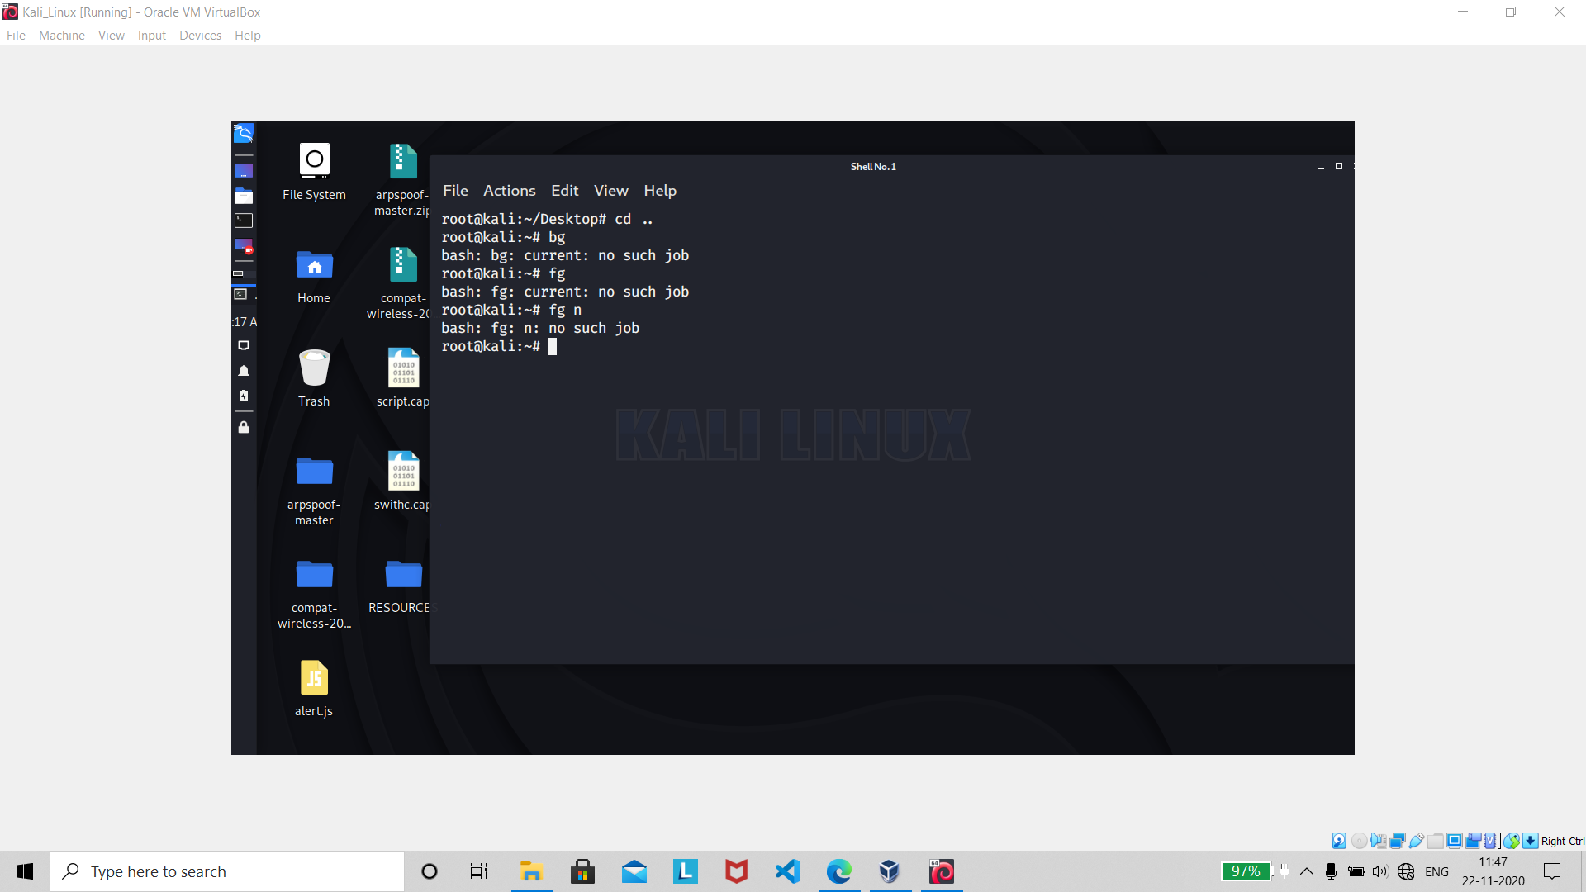

About : **Brings job n to the foreground**

***System Info***

Command :date

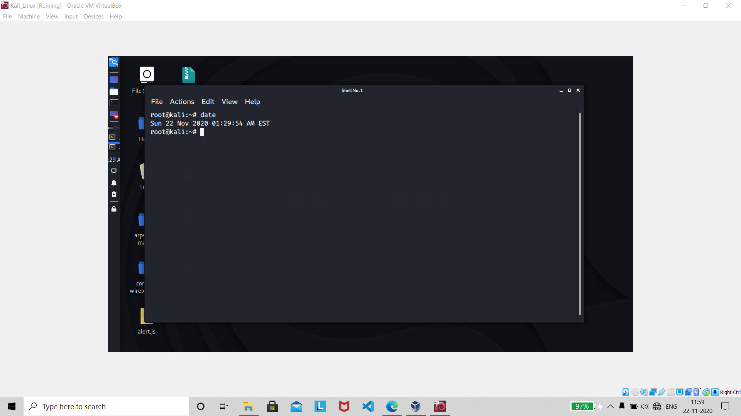

About : **The date command displays or sets the system date. It is most commonly used to print the date and time in different formats and calculate future and past dates**

Command : cal

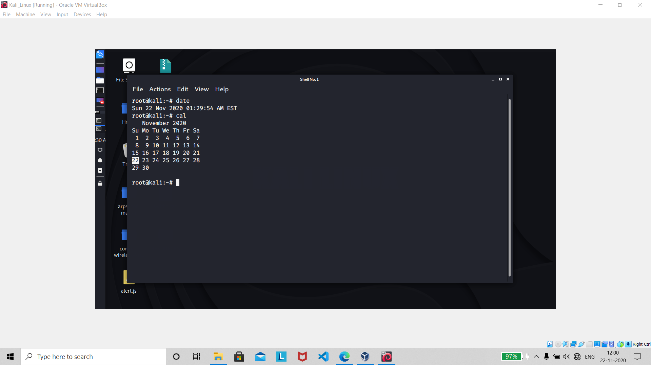

About : **cal is a standard program on Unix and Unix-like operating systems that prints an ASCII calendar of the given month or year**. **If the user does not specify any command-line options, cal will print a calendar of the current month.**

Command : uptime

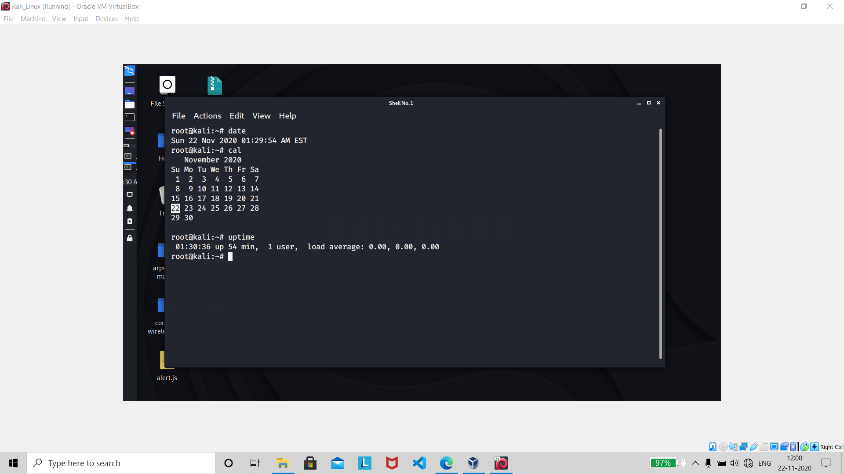

About : **Uptime Command In Linux: It is used to find out how long the system is active (running). This command returns set of values that involve, the current time, and the amount of time system is in running state, number of users currently logged into, and the load time for the past 1, 5 and 15 minutes respectively.**

Command : w

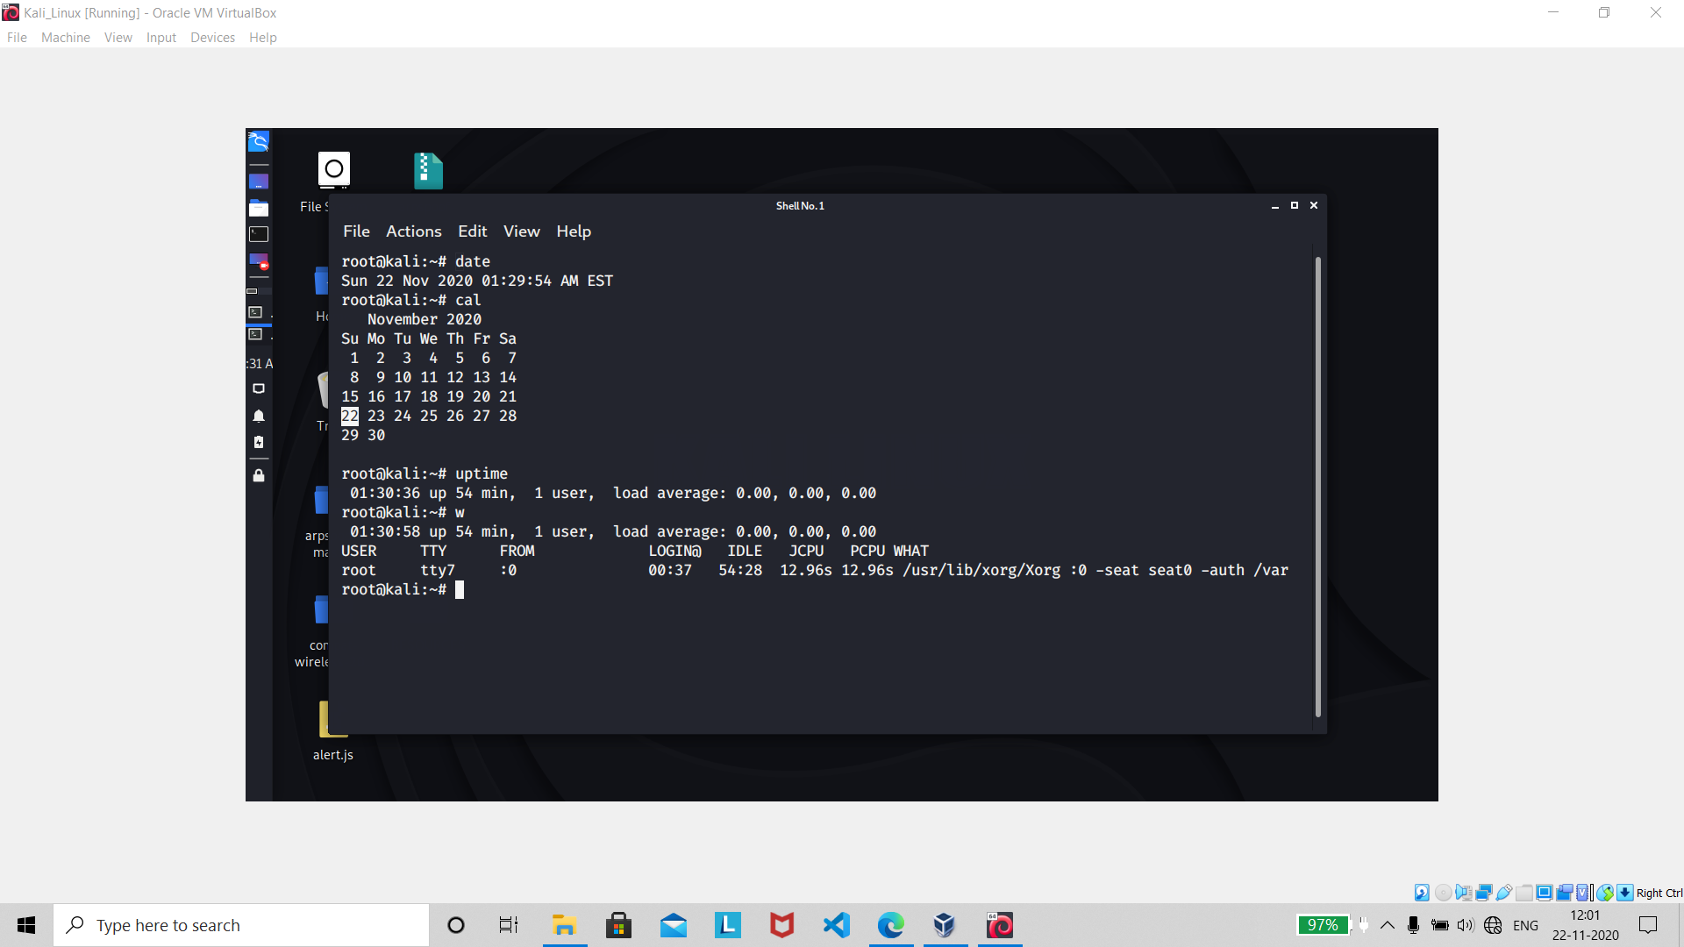

About : **On Unix-like operating systems, the w command is a quick way to** **see who is logged on and what they are doing**

Command : whoami

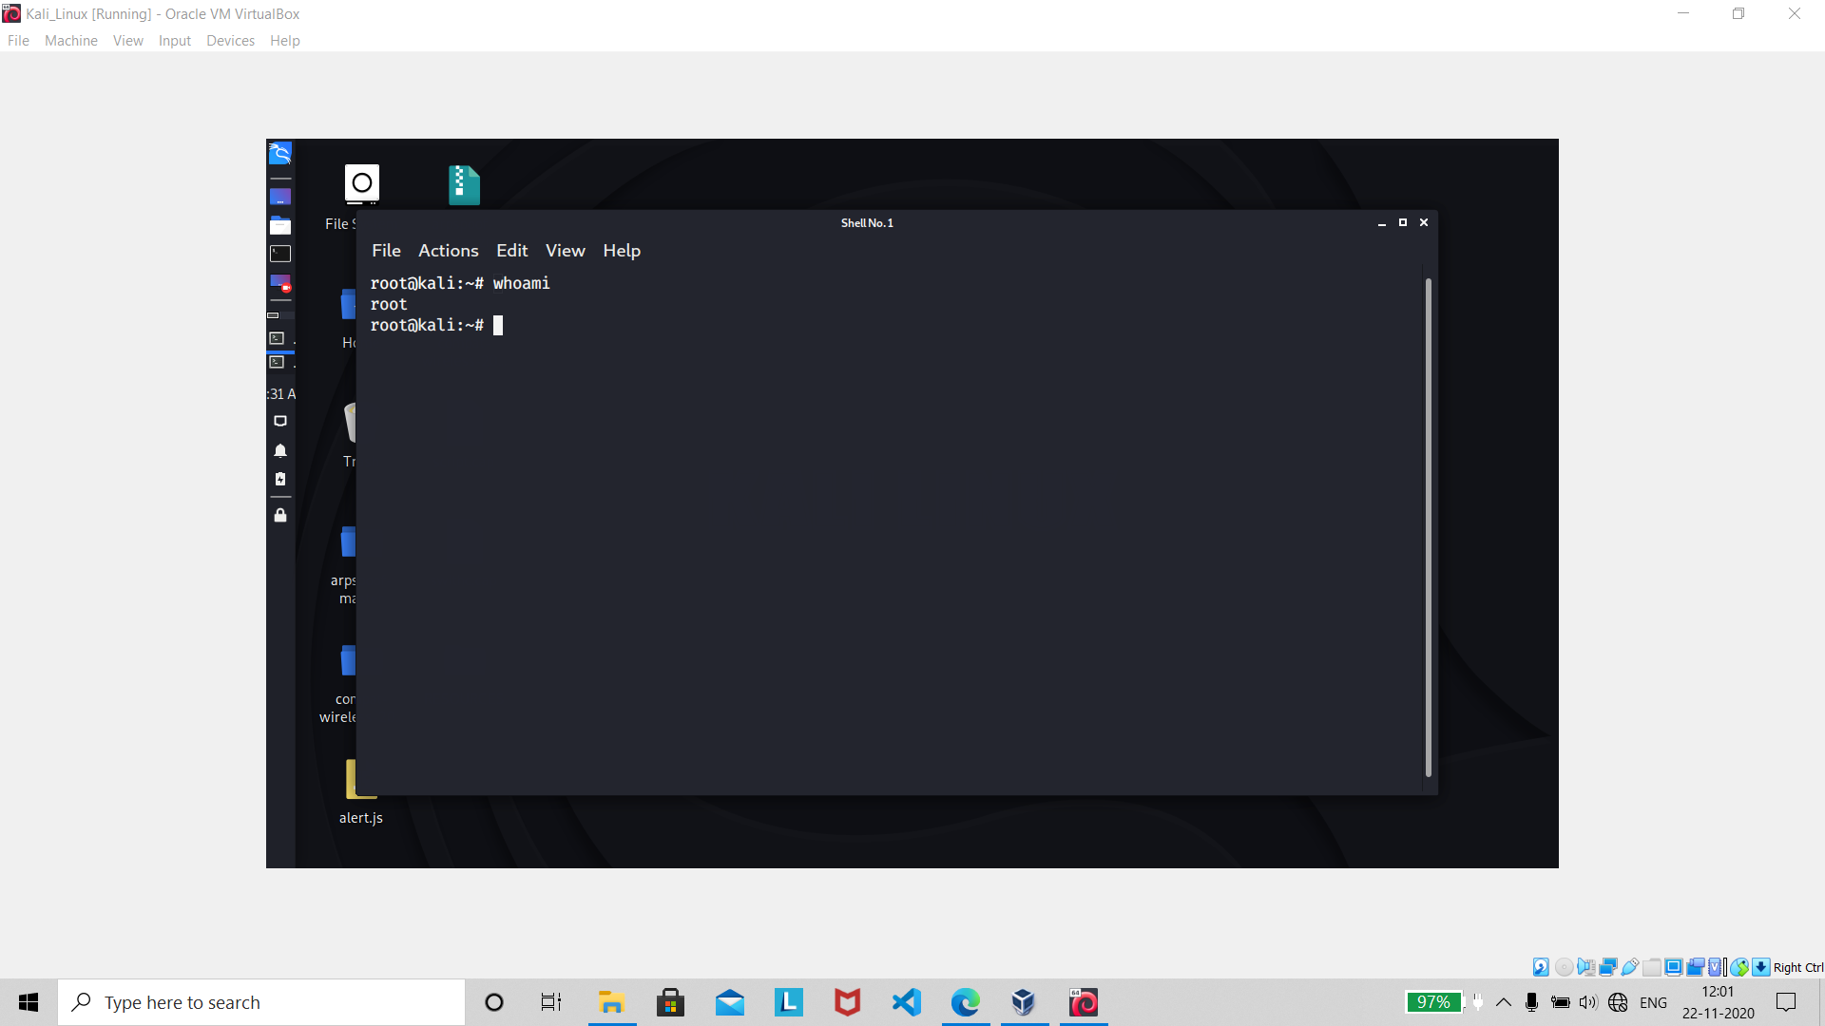

About **: The whoami command can be used in shell scripts to check the name of the user running the script. And who you are logged in as.**

Command : finger user

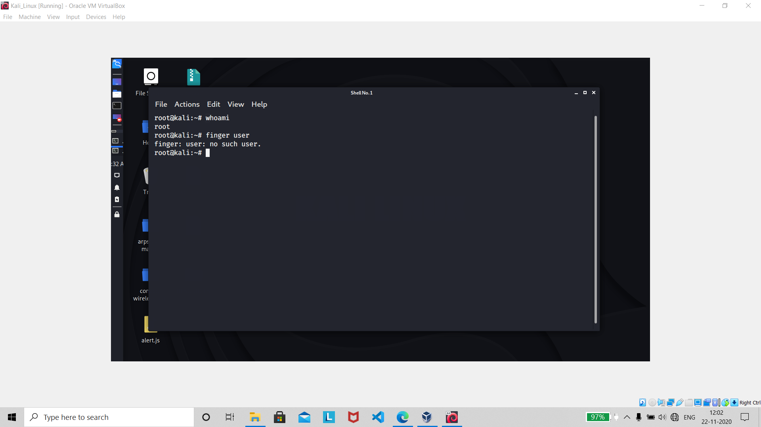

About **: It is used to get system user details like user, home directory, last login, user shell etc. This command is useful to see these parameters which otherwise you have to look under /etc/passwd and last login records. Sometimes you will not find finger command in your out of box distribution**.

Command : uname -a

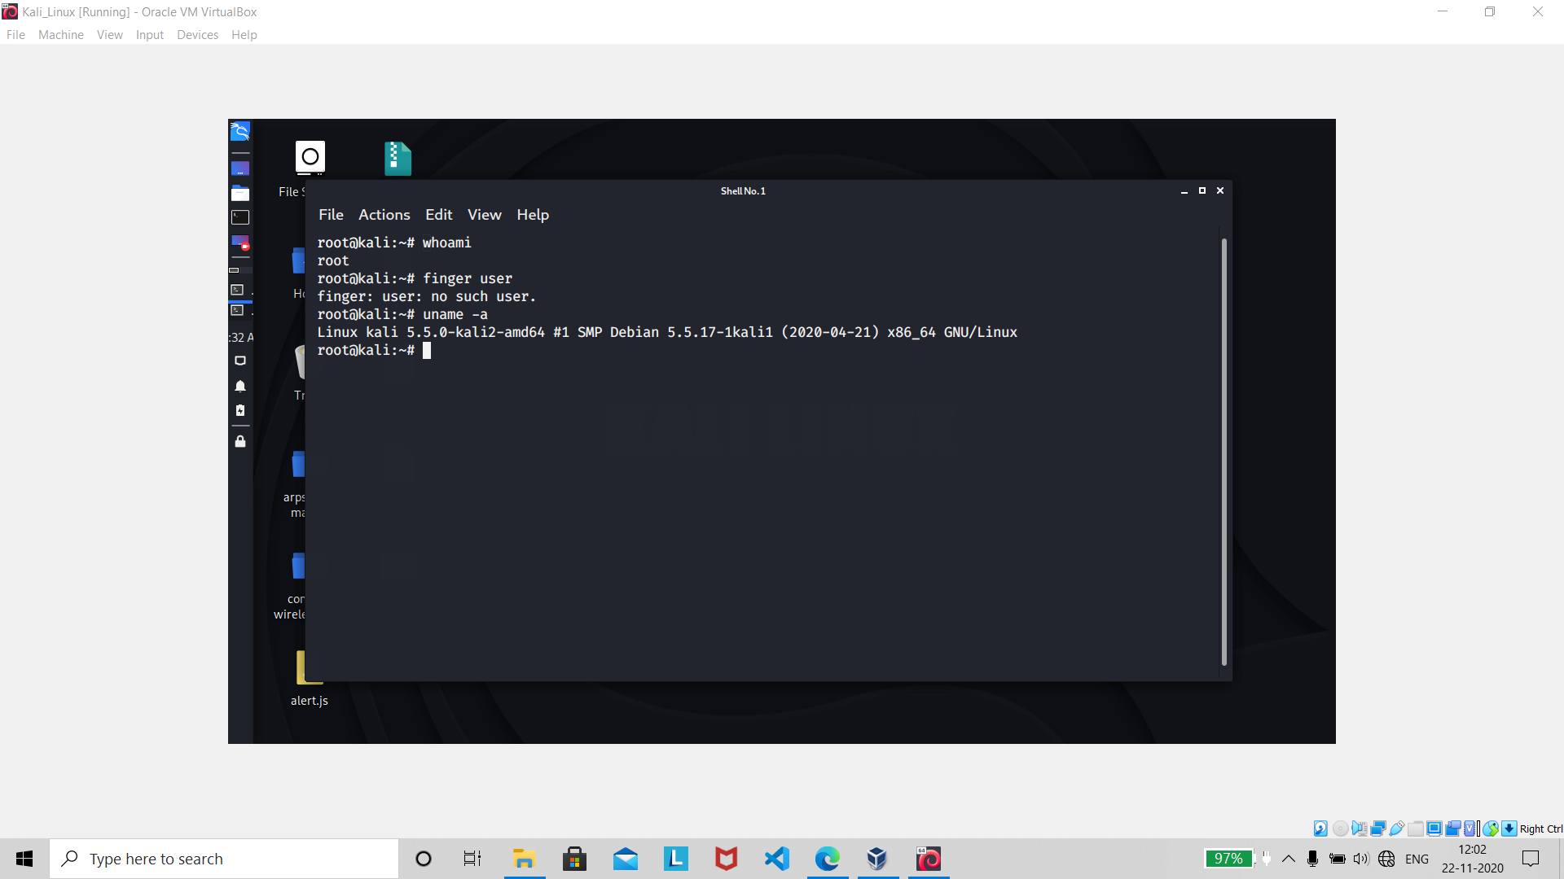

About : **uname is a command-line utility** that **prints basic information about the operating system name and system hardware**. **The uname tool is most commonly used to determine the processor architecture, the system hostname and the version of the kernel running on the system**.

Command : cat/proc/cpuinfo

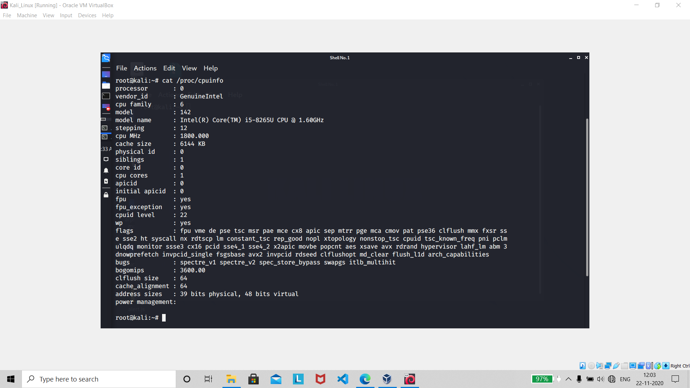

About : Show CPU information

Command : cat/proc/meminfo

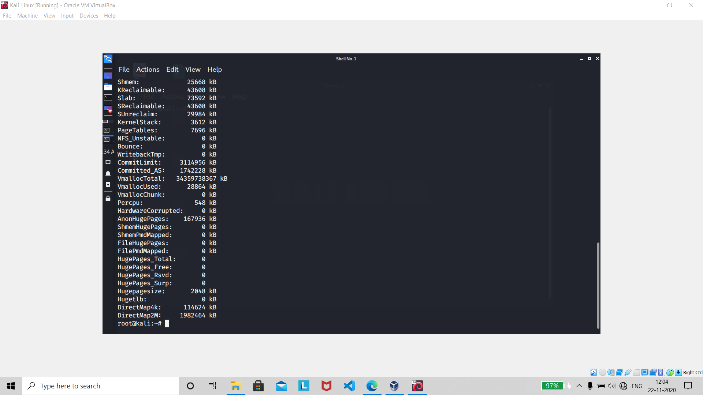

About : Shows Memory Information

Command : man rm(command)

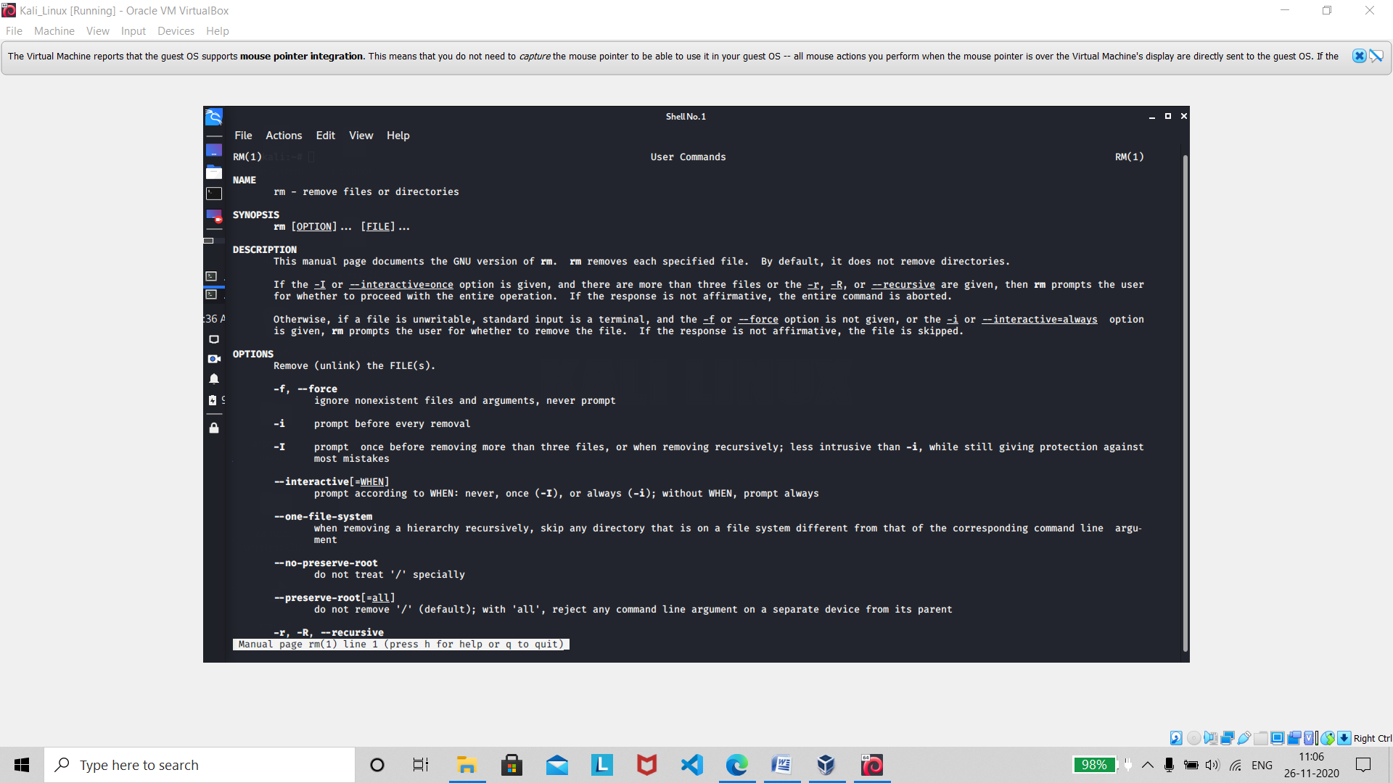

About **: The man command is used to format and display the man pages** . **The man pages are a user manual that is by default built into most Linux distributions (i.e., versions) and most other Unix-like operating systems during installation.**

Command : df

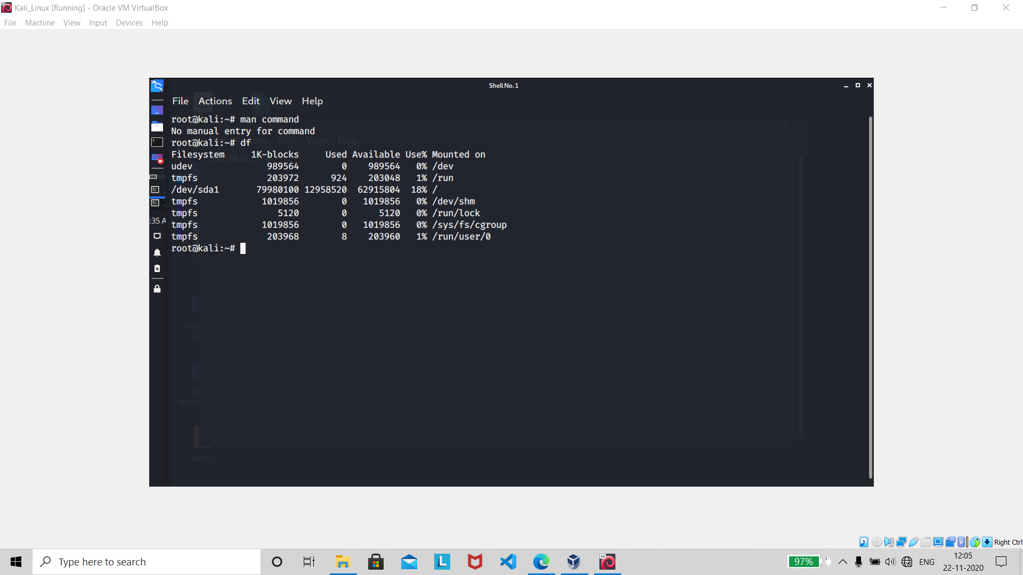

About : **The df command (short for disk free), is used** to **display information related to file systems about total space and available space.**

Command : du

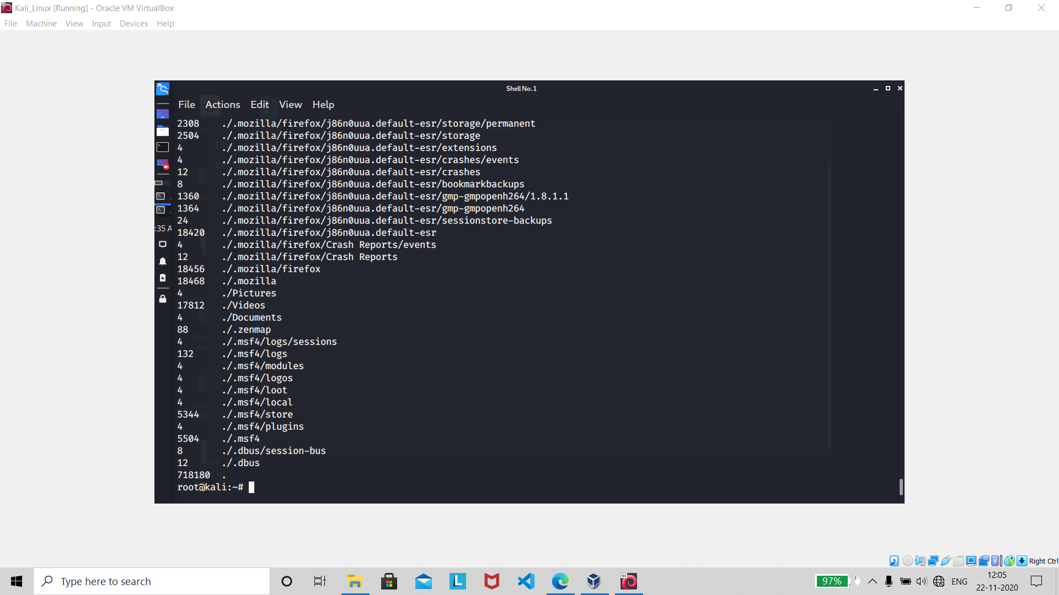

About **: du command, short for disk usage, is used to estimate file space usage. The du command can be used to track the files and directories which are consuming excessive amount of space on hard disk drive**

Command : free

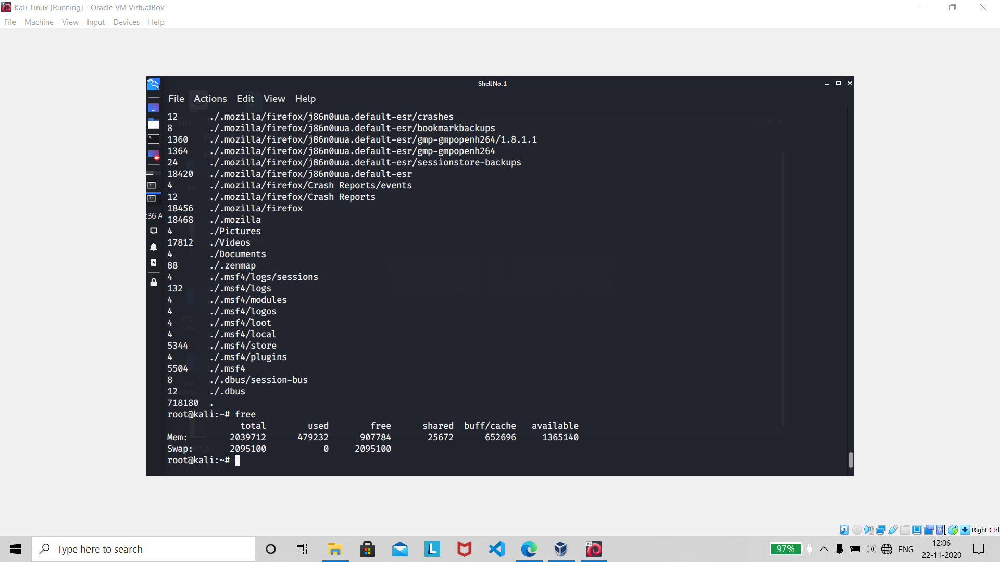

About : **On Unix-like operating systems, the free command** **displays the total amount of free and used physical and swap memory**, **and the buffers used by the kernel.**

Command : whereis app

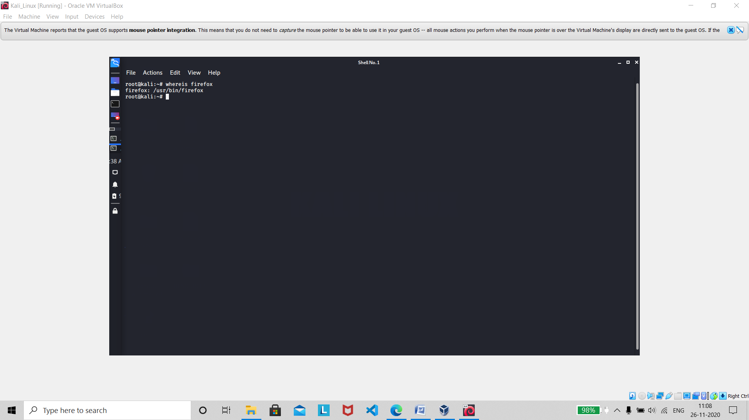

About : **The whereis command in Linux is used to** **locate the binary, source, and manual page files for a command**. **This command searches for files in a restricted set of locations (binary file directories, man page directories, and library directories).**

***Compression***

Command : tar cf file.tar file

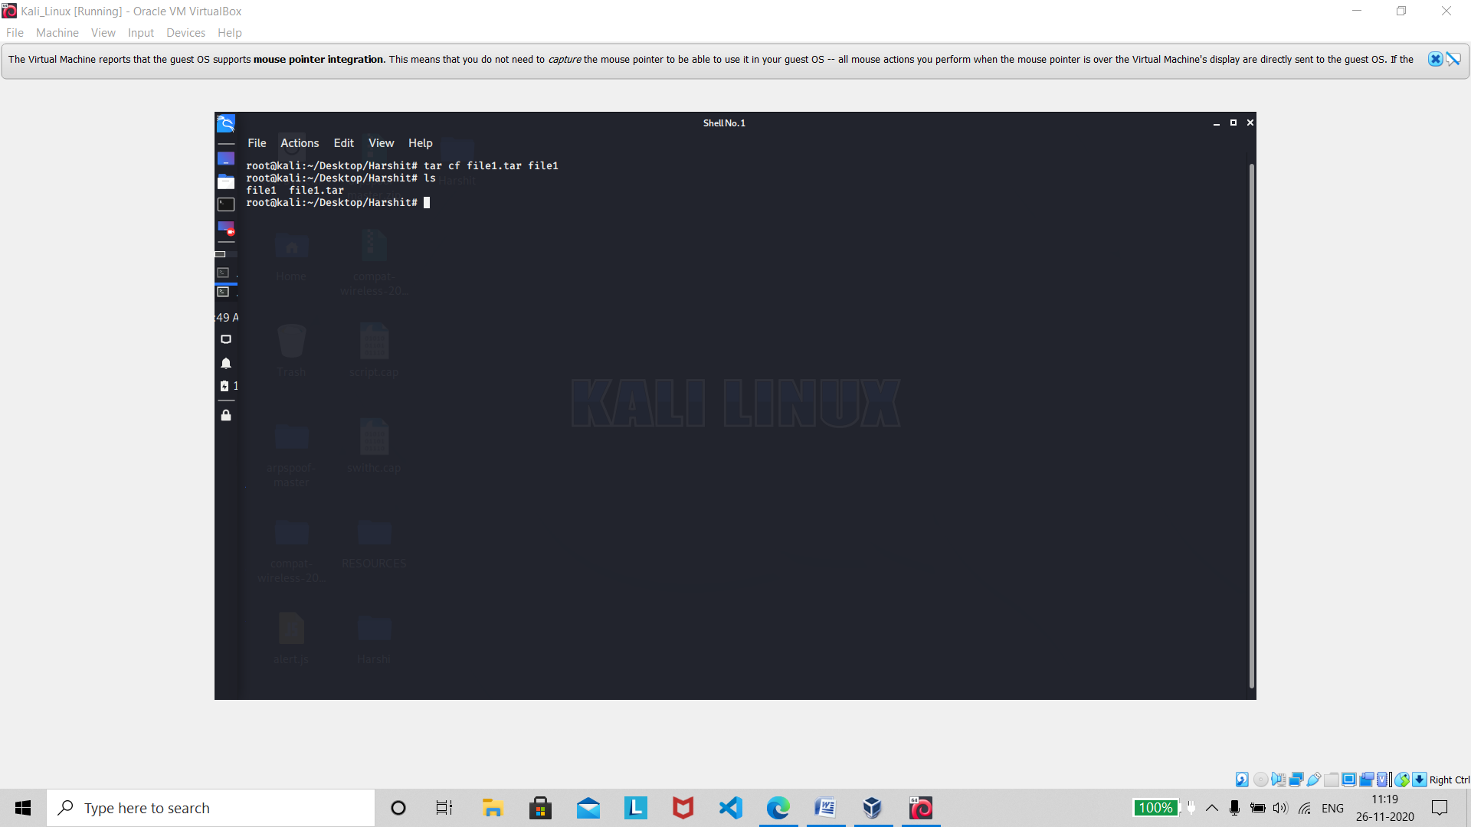

About : **Create tar named file.tar containing file**

Command : tar xf file.tar

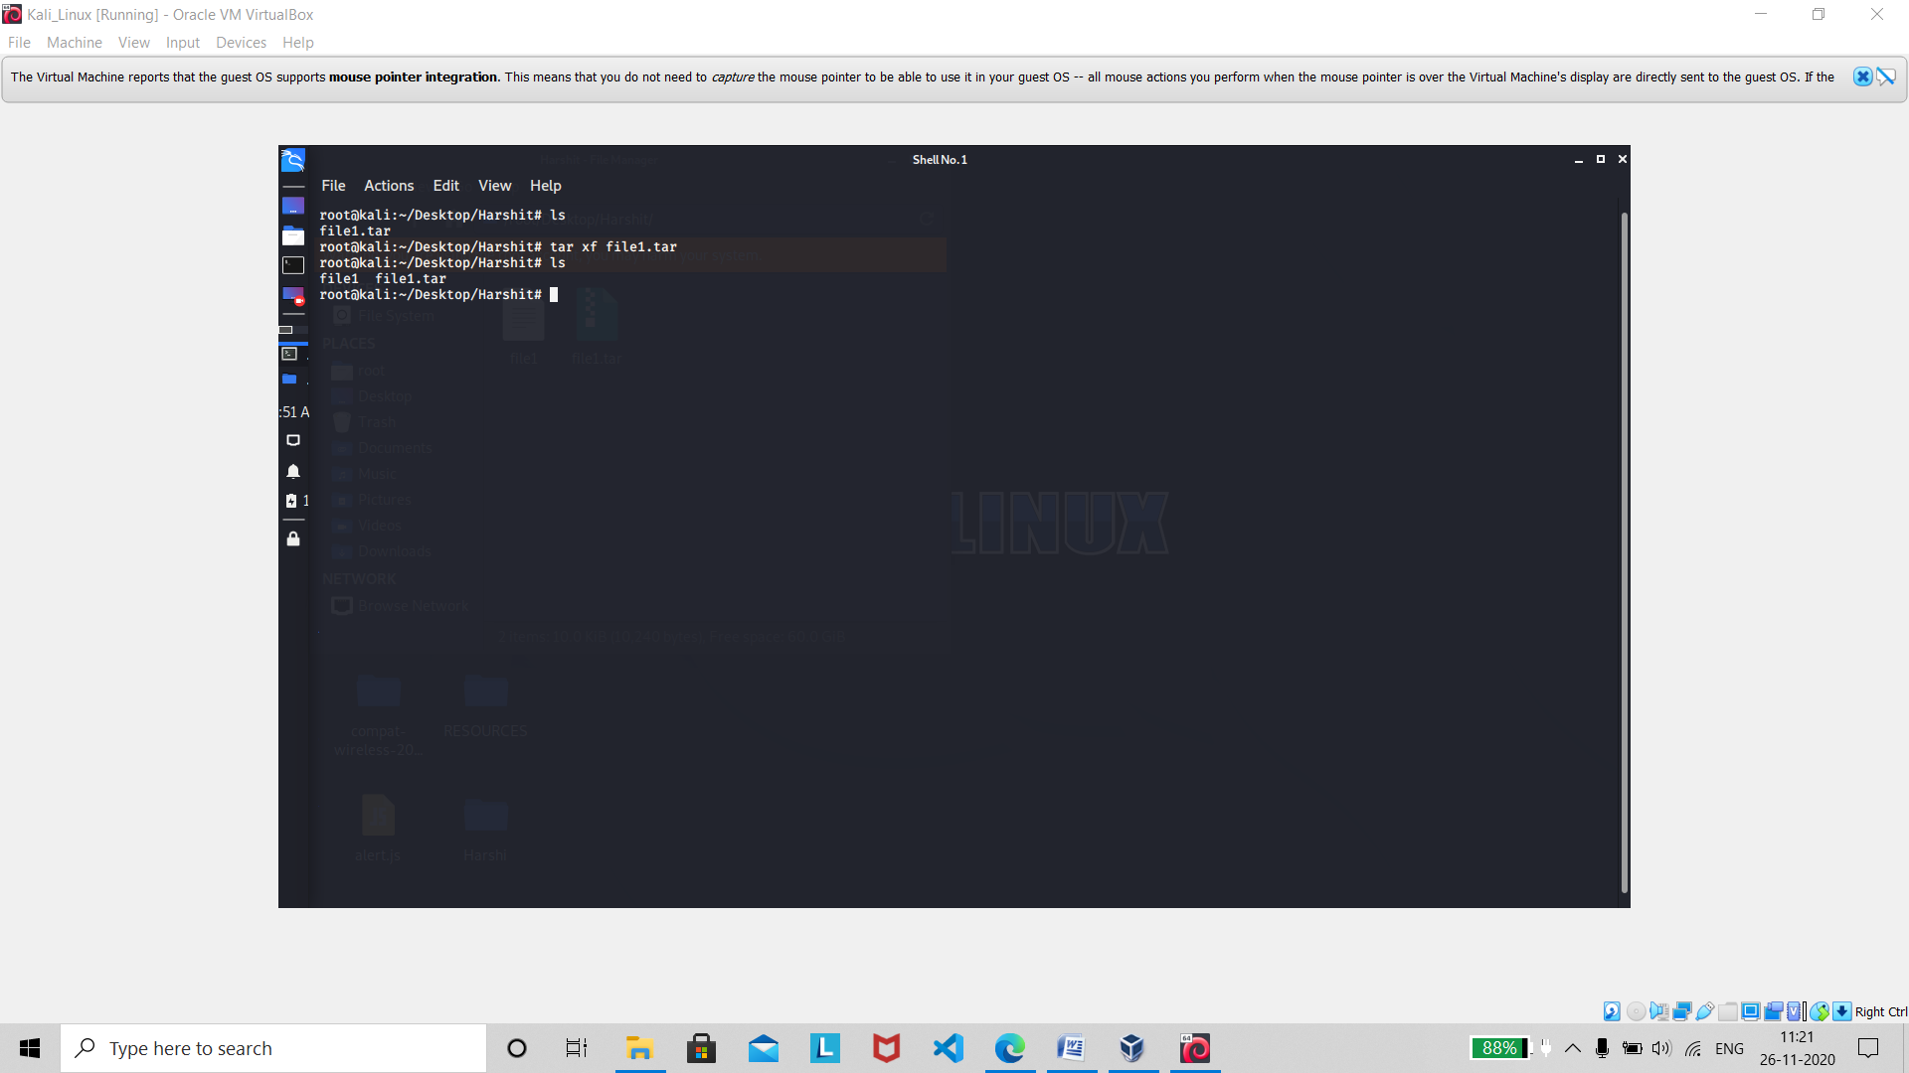

About : **Extract the files from file.tar**

Command : tar czf file.tar.gz file

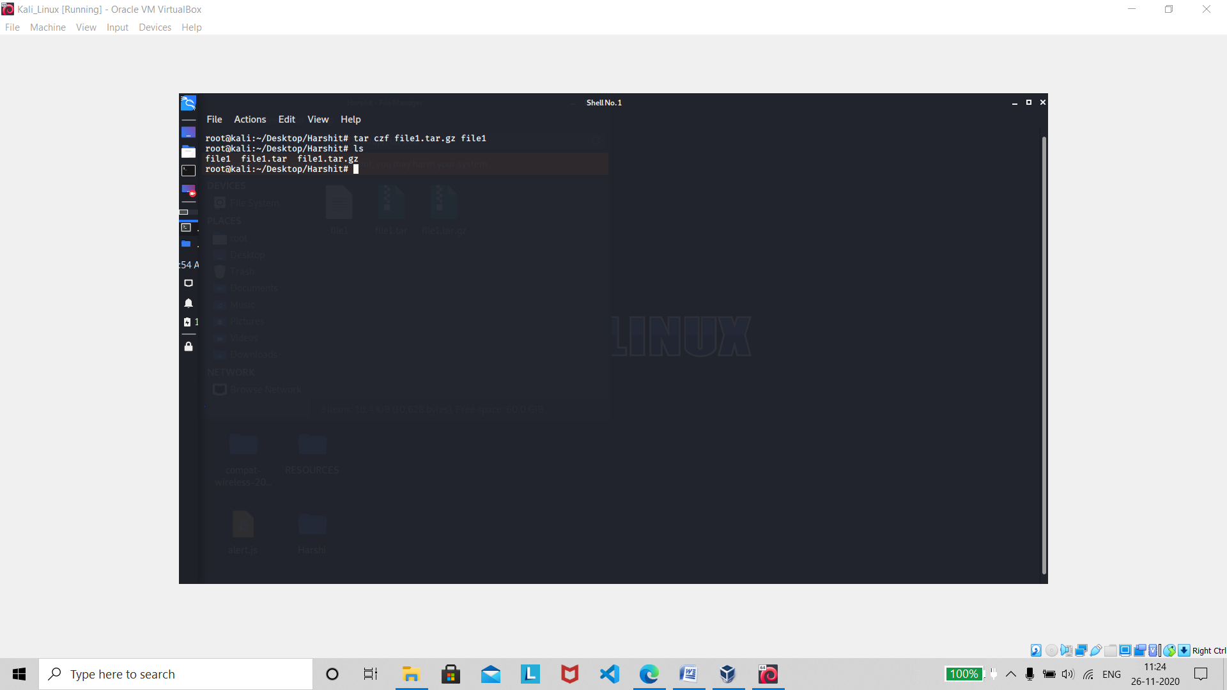

About : **Create a tar with Gzip compression**

Command : tar xzf file.tar.gz

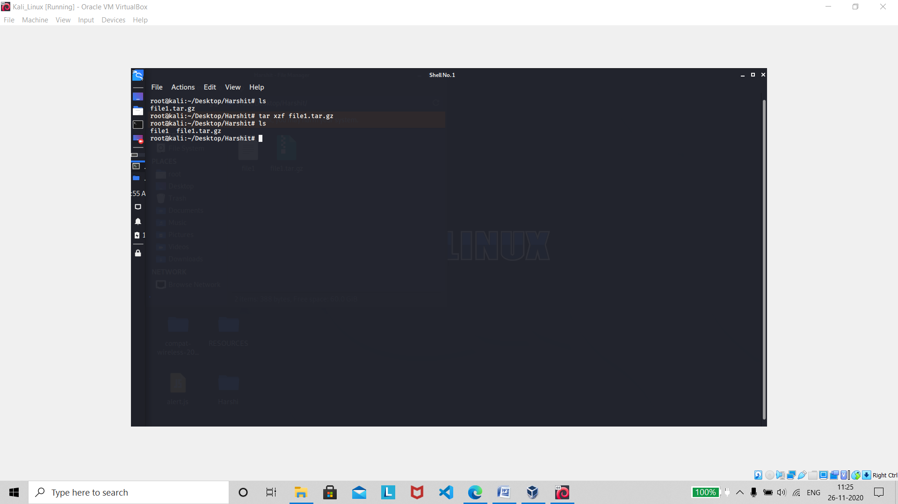

About : **Extract a tar using Gzip**

Command : gzip file

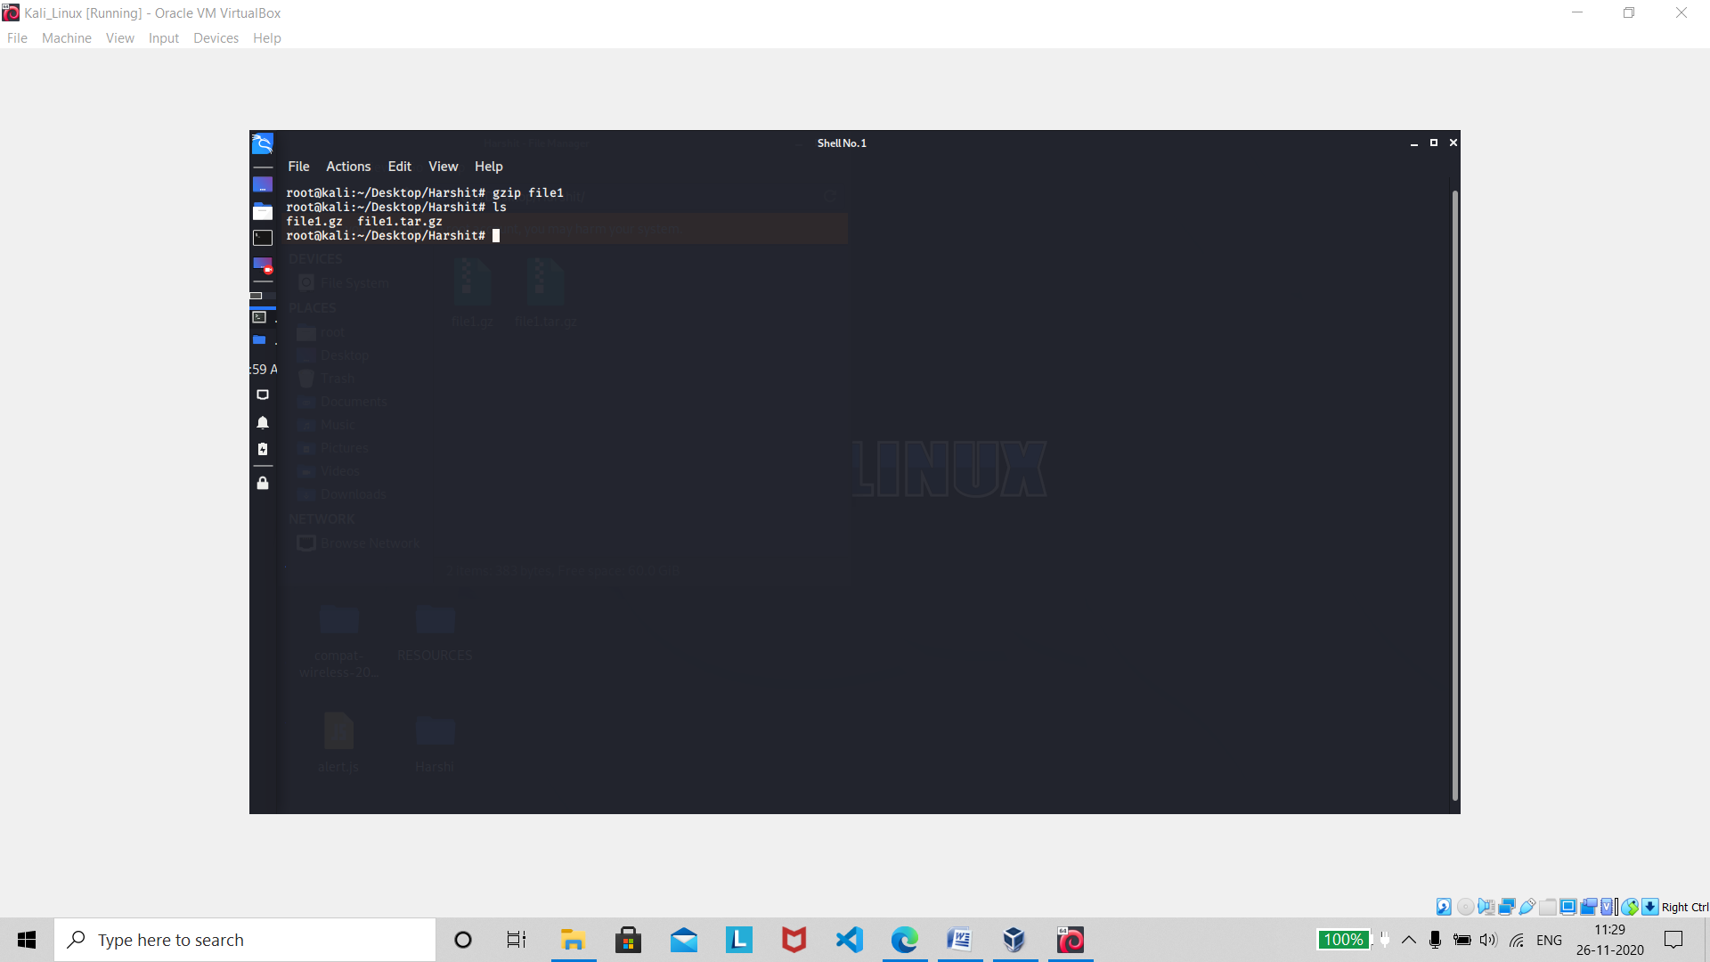

About : **Compresses file and renames it to file.gz**

Command : gzip –d file.gz

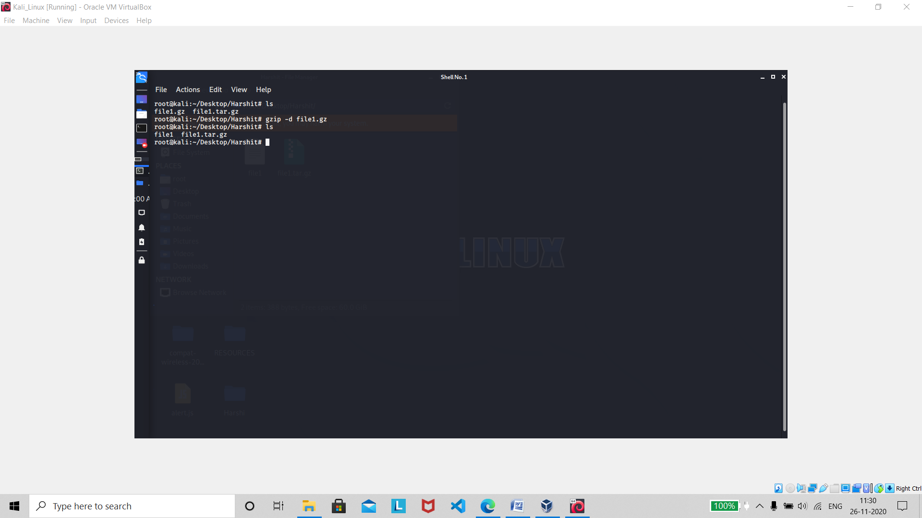

About : **Decompresses file.gz back to file**

***Network***

Command : ping host

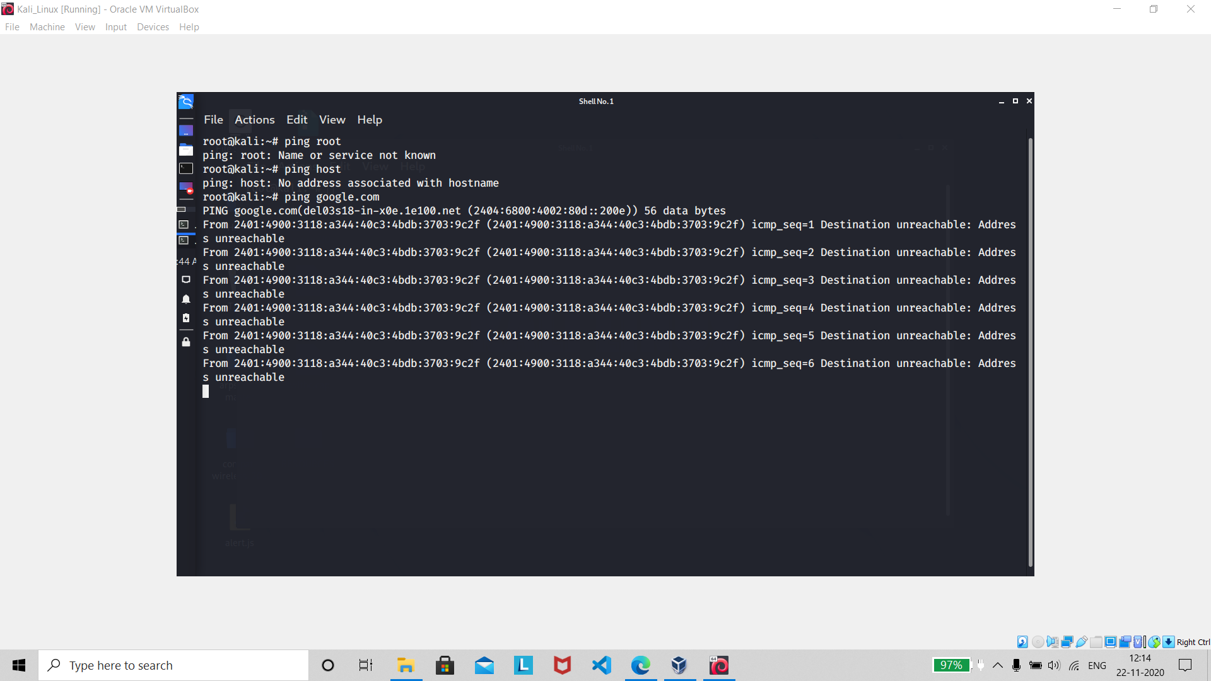

About : **The ping command sends packets of data to a specific IP address on a network, and then lets you know how long it took to transmit that data and get a response. It’s a handy tool that you can use to quickly test various points of your network.**

Command : whois domain

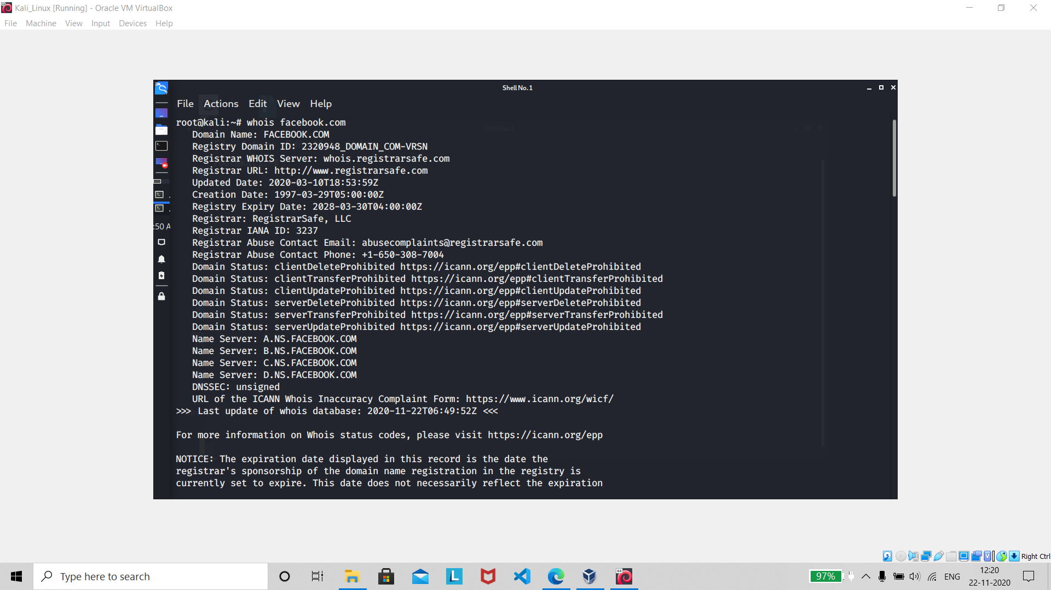

About : **whois is a command line utility that fetch information about ownership of a domain name from whois server (whois database). WHOIS is a query and response protocol that is widely used to gather information about registered domain name**.

Command : dig domain

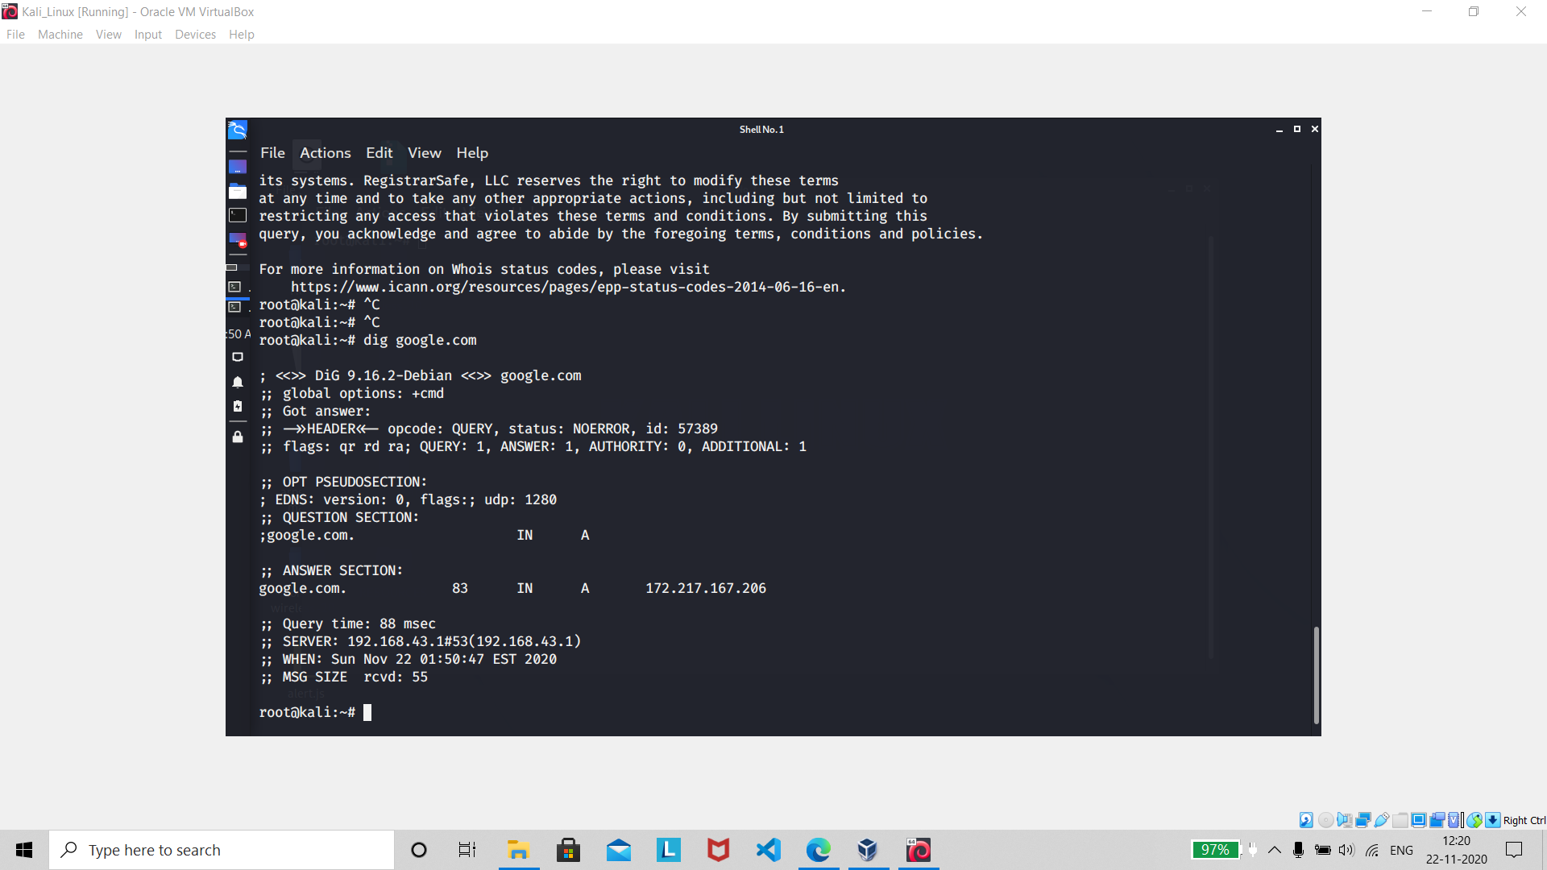

About : **People use the Linux dig command to query Domain Name System (DNS) servers. dig is an acronym for Domain Information Groper . With dig, you can query DNS servers for information regarding various DNS records, including host addresses, mail exchanges, name servers, and related information.**

Command : dig –x host

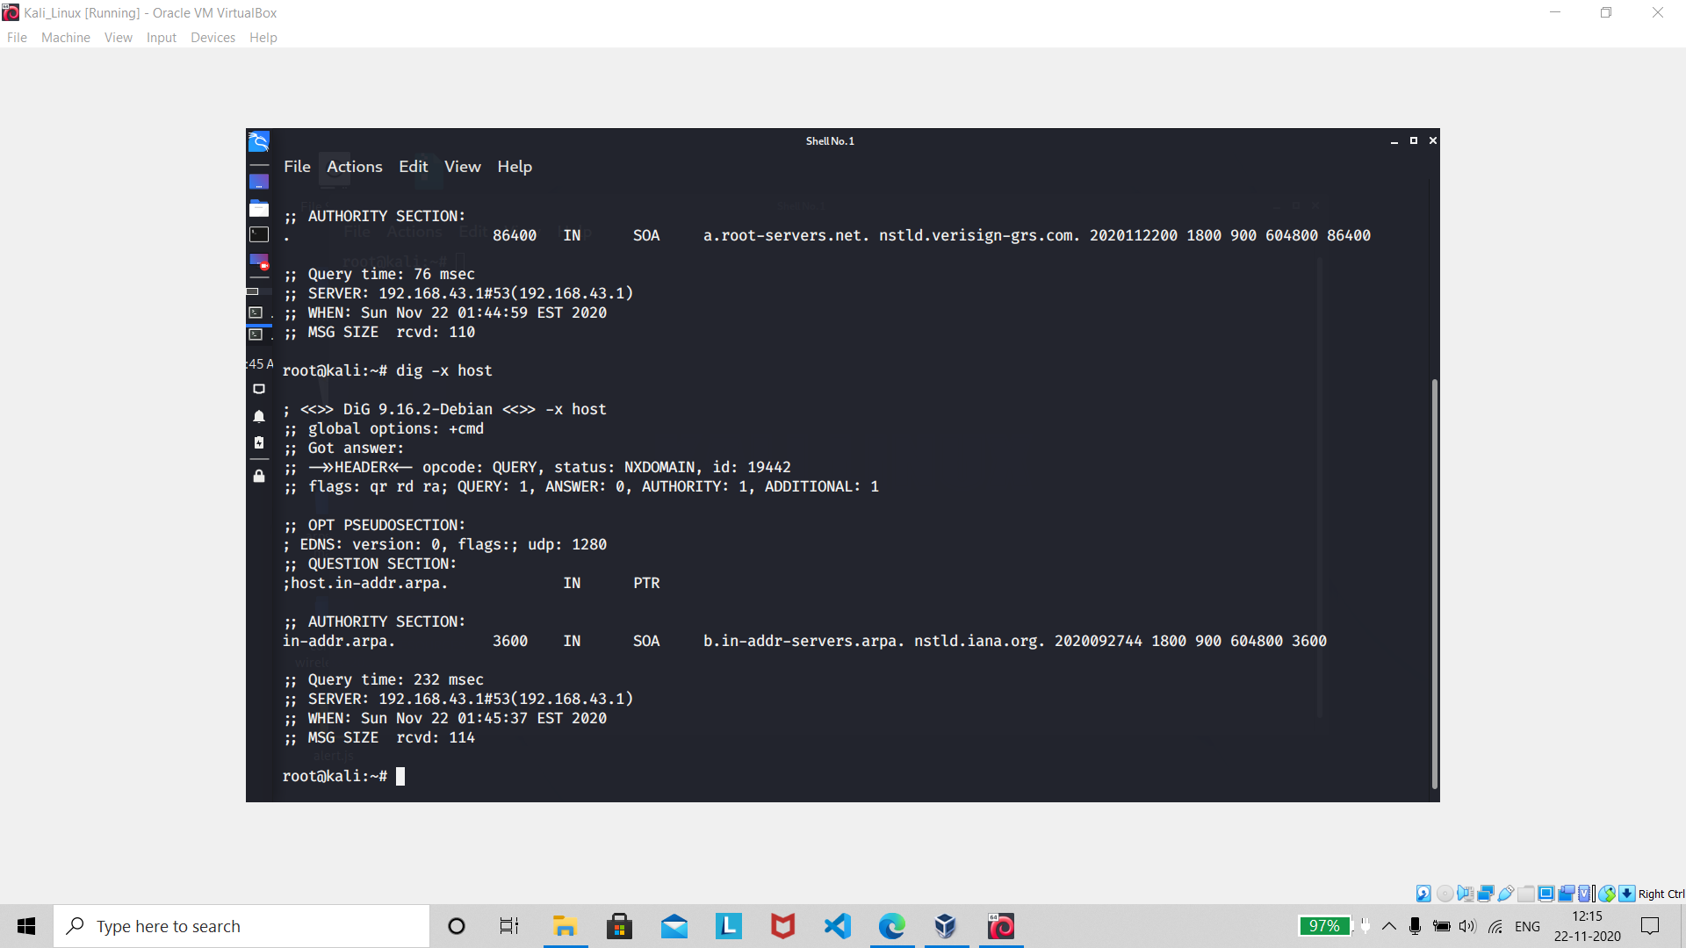

About : **Reverse lookup host**

Command : wget file

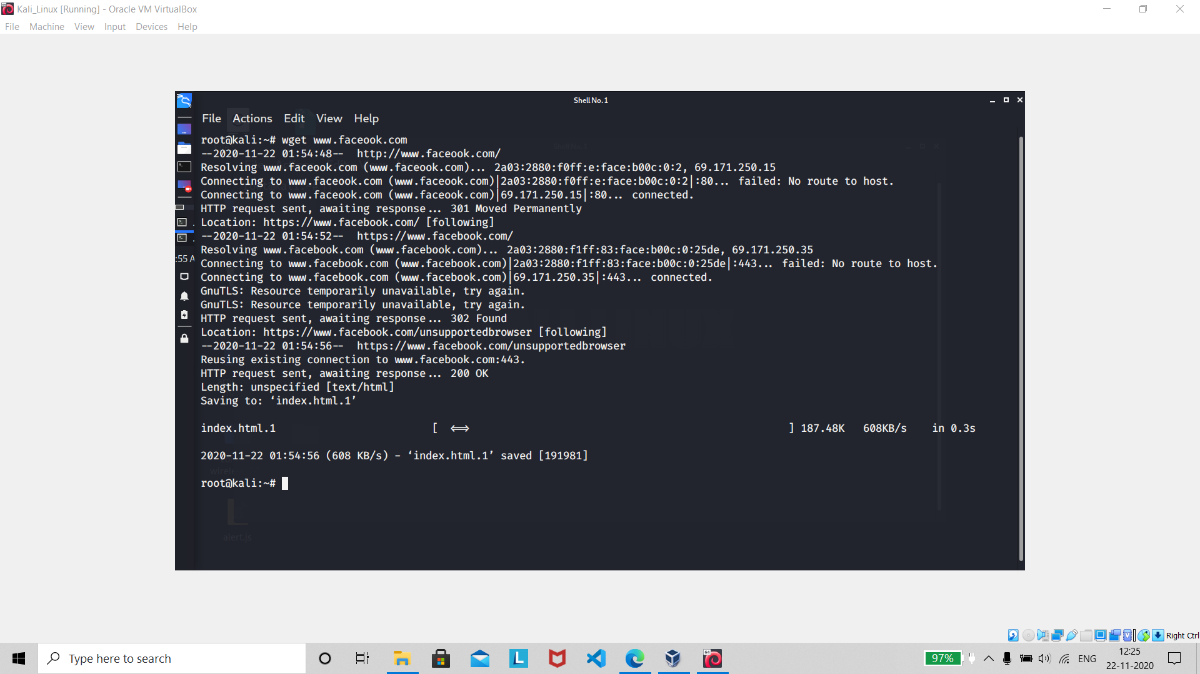

About : **The wget utility allows you to download web pages, files and images from the web using the Linux command line. You can use a single wget command on its own to download from a site or set up an input file to download multiple files across multiple sites.**

Command : wget –c file

About : **Continue a stopped Download**